Nadine Marie Smothers
October 12, 1979 - August 9, 2023
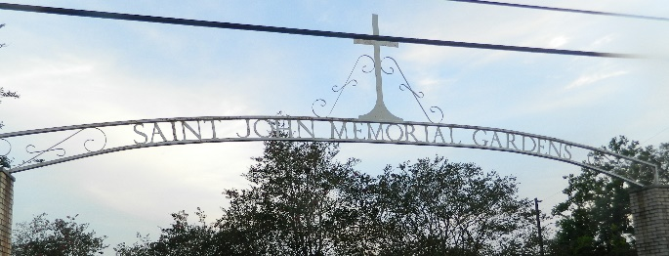

Nadine Marie Smothers was born on October 12, 1972 at Charity Hospital, New Orleans, LA to Charles Bertrand Smothers, Jr., and the late Pamela Perrilloux Smothers. At an early age her parents were informed that Nadine was born with a medical condition that caused vision loss and the loss of the ability to walk and speak. She underwent eye surgery, but it was unsuccessful. Despite her condition, Nadine was a vibrant, happy little girl. Her vibrant personality remained through her adult life. She was blessed to have the care of her mother and siblings. Even though she lived most of her life apart from her father, she was deeply loved by him. The Lord made the call for Nadine to get her wings and join him in Heaven on August 9, 2023.
She leaves to cherish her memories her father Charles Bertrand Smothers, Jr., grandmother, Myrtle Jenkins Smothers, three brothers; Charles Bertrand Smothers, III, Jarred Justin Smothers and Garrick Michael Smothers, two sisters; Jessica Lynn Smothers and Shelita Rene’ Smothers, Aunts; Yvonne Marie Smothers Bailey, Marva Louise Smothers Dents, Shelia Ann Smothers, Elizabeth Thomas, Loutricia Batiste and Patronella Williams, Uncles; David Lee Smothers, Rev. Wilfred Thomas Smothers, Sr., Kevin Smothers, Bryan Smothers, Dwayne Smothers, Jason Kyle Smothers, Adrian Perrilloux, Bruce Perrilloux, Carl Perrilloux, Otis Perrilloux, Quincy Perrilloux, Joseph Perrilloux, Timothy Perrilloux, Sisters-in-law; Stella Smothers, Katrina Smothers, Brother-in-law; Michael Harris, Sr., and numerous nieces, nephews and cousins.
She was preceded in death by her mother Pamela Perrilloux Smothers; grandparents Charles Bertrand Smothers, Sr., and Romey Perrilloux, Grandmother Margarite Perrilloux; Aunt; Cheryl Perrilloux; Uncle Remey Perrilloux, III and Dale Perrilloux.
Relatives and friends of the family are invited to a Home Going Celebration at 10:00am on Thursday, August 17, 2023 at the Patrick H. Sanders Funeral Home, 605 Main Street, LaPlace, LA 70068. Visitation 9:00am until time of service at the above-named location. Interment St. John Memorial Gardens, 2205 W. Airline Hwy, LaPlace, LA 70068. Final Arrangements Entrusted to Patrick H. Sanders Funeral Home & Funeral Directors, Inc. 605 Main Street, LaPlace, LA 70068, 985-359-1919.

Patrick H. Sanders Funeral Home, LaPlace, Louisiana

