Pamela (Perrilloux) Smothers
July 19, 1950 – June 2, 2023
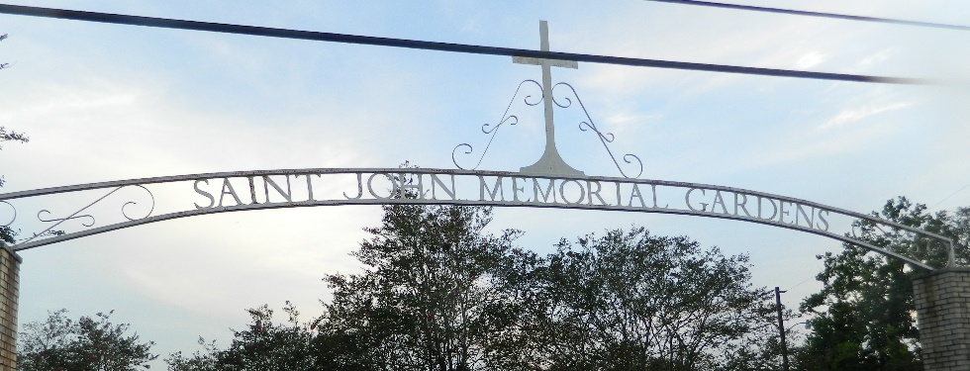

Pamela Perrilloux Smothers, affectionately known as "Granny" by those close to her, was born July 19, 1950, in Reserve, LA, to the Late Remey, Jr. and Margurite Perrilloux. Pamela was called to her heavenly home on June 2, 2023, at the age of 72.
Pamela leaves to cherish her precious memories, two daughters, Nadine Smothers of Dallas, TX, Jessica Harris (Michael) of Dallas, TX. Three sons Charles B. Smothers, III (Charles Billings) of Dallas, TX, Jarred Smothers (Shanell) of Laplace, LA, and Garrick Smothers (Katrina) of Laplace, LA. Two bonus daughters, Shelita Smothers of Laplace, LA, Shara Spry (Allen) of Atlanta, GA. She was the grandmother of Ebony Holmes, Charles Smothers, IV, Imani Nicholson, Desan Signal, Ajaden, Lauren, and Payton Smothers, Amariah, Isreal and Journi Smothers, Makayla Duffy, Mariah, Robert, Donavon, Daelin and K'amryn. The great grandmother of Kali Royal Holmes, Charles Smothers V. (Bert), Amaj Judah Nicholson, Prince, and Mckinlee. Four Godchildren, Penny Jones, Alicia Jack, Quinell Perrilloux Rogers and Galline Perrilloux. Three sisters Elizabeth Thomas, Loutricia Batiste, Patronell Williams. Seven brothers Otis, Bruce, Carl, Adrian, Quince, Joseph, and Timmy Sr., Perrilloux. She also leaves a host of nieces nephews, cousins, and friends.
Pamela is preceded in death by her parents Remey, Jr. and Margurite Perrilloux. Brothers, Remy Perrilloux, III and Dale Perrilloux, Sr. Sister, Cheryl Frank, Two Nieces, Dentria Fisher, and Kim Paxton, One Brother -N- Law, Robert Williams.
Relatives and friends of the family are invited to attend a Celebration of Life at 10:00 AM on Saturday, June 17, 2023, at New Wine Christian Fellowship, 1929 W. Airline Hwy, Laplace, LA. 70068. Visitation 9:00am until time of service at the above-named church. Interment St. John Memorial Gardens, 2205 W. Airline Hwy, Laplace, LA. Final Arrangements Entrusted to Patrick H. Sanders Funeral Home and Funeral Directors, Inc. 605 Main Street, Laplace, LA 70068. 985-359-1919.

Patrick H. Sanders Funeral Home, LaPlace, Louisiana

