Arthur Rubin Snyder
August 17, 1922 – October 20, 1976
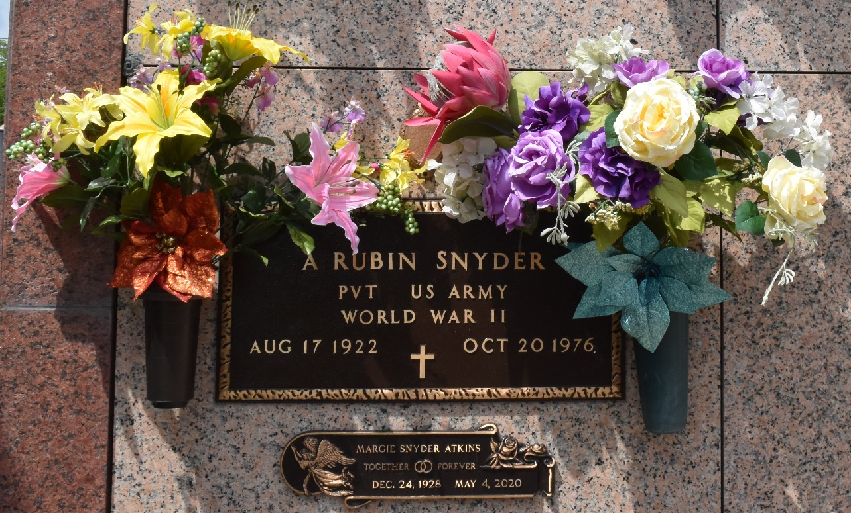

Funeral Services for A. Rubin Snyder of LaPlace were held Friday, Oct. 22 from the Alexander Funeral Home in LaPlace, with interment in St. John Memorial Gardens in LaPlace. Mr. Snyder died Wednesday, Oct. 20 on the George Prince ferry.
He is survived by his widow, Margie Snyder; four sons, Frank, Charles, Tommy and Mark Snyder; one daughter, Linda Scallan; his father Arthur J. Snyder of Jackson, Miss.; two brothers, Luther Snyder, W. D. Snyder of Isola, Miss.; two sisters, Floyce Summeral of Jackson, Miss. And Sally Parker of Ocean Springs, Miss., and 10 grandchildren.
L'Observateur, Reserve, Louisiana
October 28, 1976
p. 4

