Margie Lucille (Suggs) Snyder-Atkins
December 24, 1926 – May 4, 2020
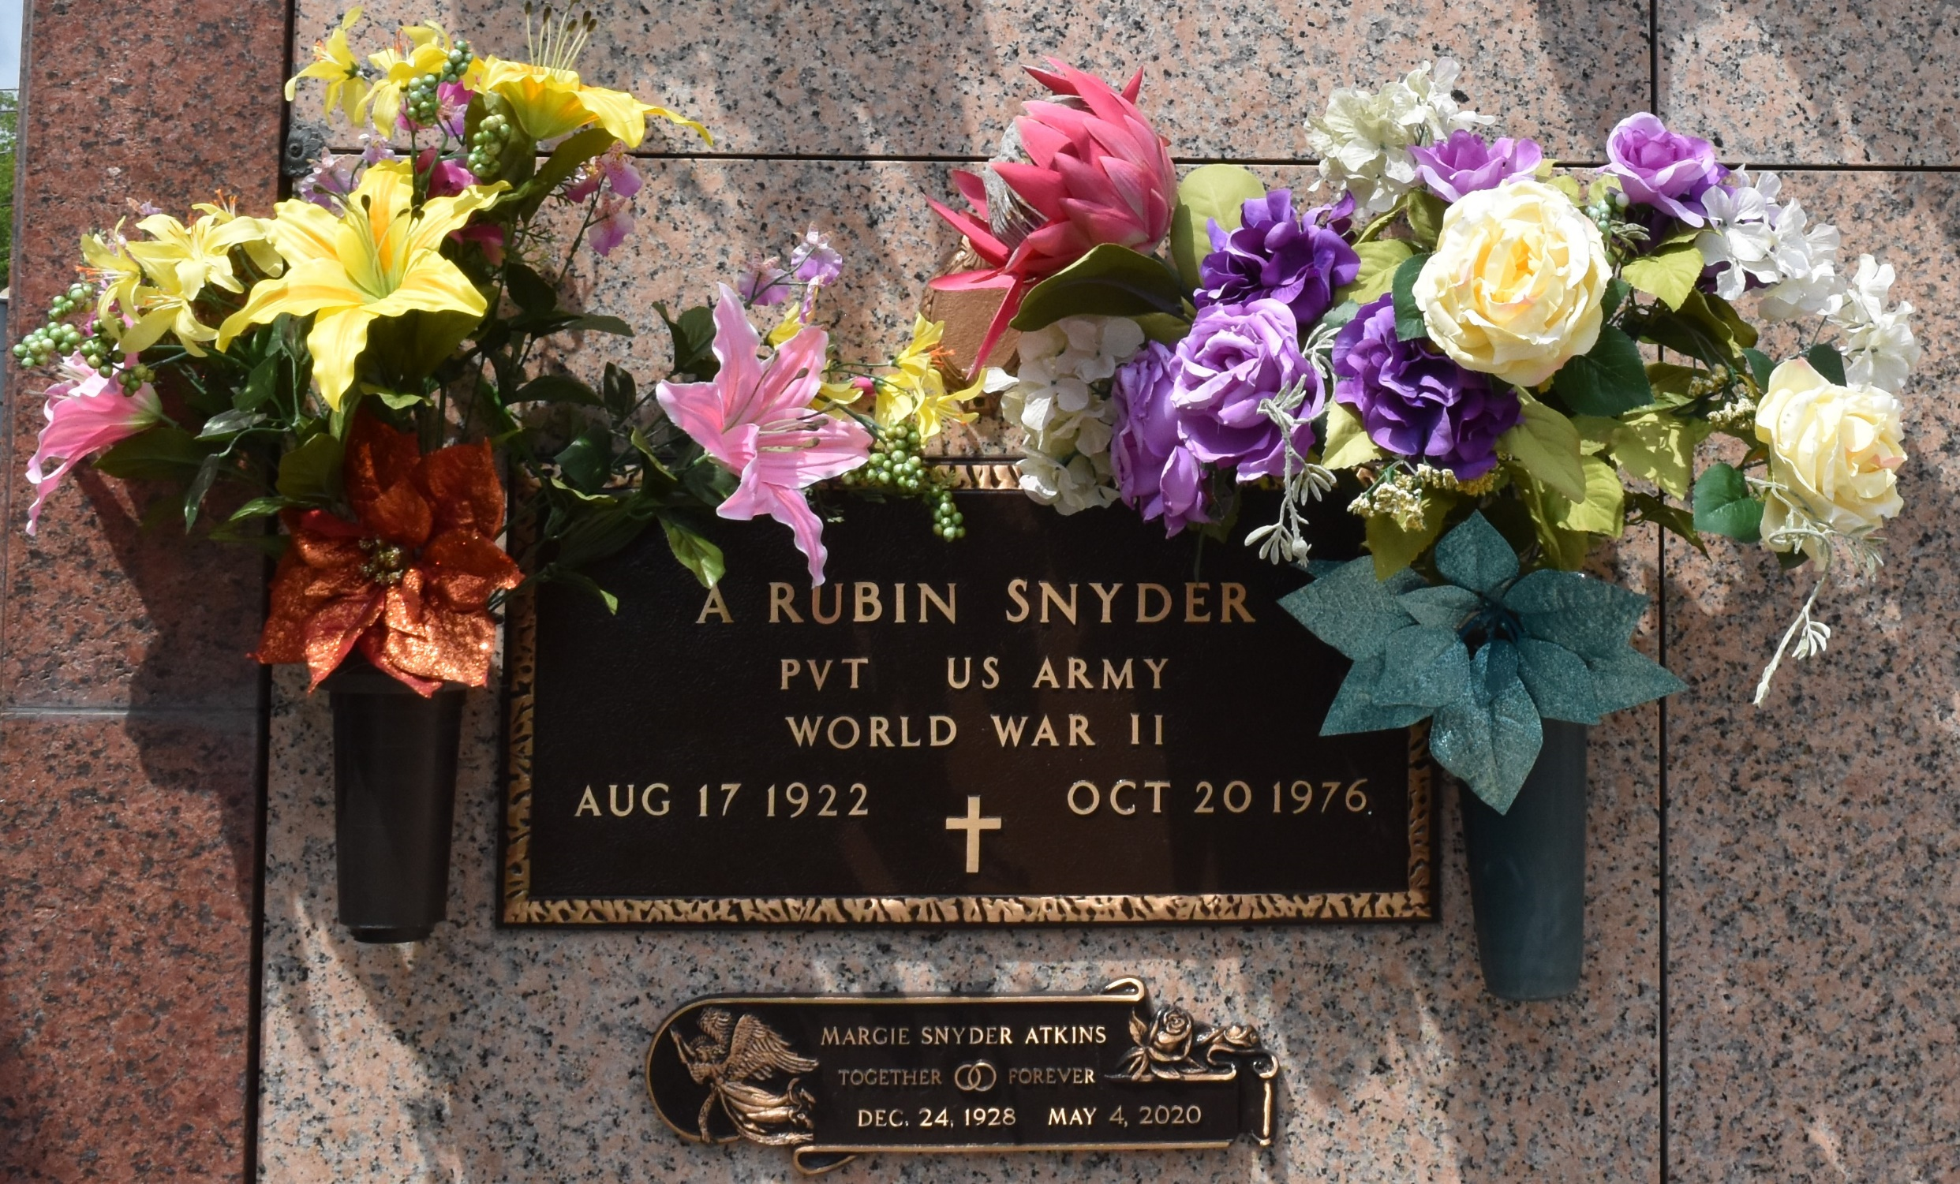

Margie Lucille Snyder Atkins passed away on Monday, May 4, 2020 at the age of 91. She was a native of Morehead, MS and a resident of Kenner, LA. Beloved wife of the late Arthur Rubin Snyder by first marriage and the late Dorris Atkins by second marriage. Loving mother of Frank Snyder (Mia), Charles Snyder (Darlene), Tommy Snyder (Cynthia), Mark Snyder (Cindi) and Linda C. Scallan (E.J.). Stepmother of Phillip Atkins (Linda), Elaine Rzanca (Rick), and Terri Barksdale (Junior). Daughter of the late Bessie Whitaker Suggs and Vander D. Suggs. Sister of the late Samual "Bill"Suggs, Cecil Suggs, William Suggs, Vander Suggs, Ruth O'Dilly, Grace Hughs and Ethel Suggs. Also survived by 11 grandchildren, 21 great grandchildren and 5 step grandchildren.
Margie was a caring and loving Mother, Grandmother and Great Grandmother to all of her family. She was full of compassion and love for anyone she would meet. She was a member of First Baptist Church of Kenner for twenty plus years.
The family would like to thank the staff of Ormond Care Center and Saint Catherine's Hospice for all the care and compassion that she received in their care. As a result of present circumstances, a Memorial Service will be planned at a later date. Please consider sharing your thoughts, favorite memory or condolences at www.muhleisen.com.
The Times-Picayune, New Orleans, Louisiana
May 6 to May 8, 2020

