Donte Rashaad Snyder
July 3, 1995 – January 28, 2013
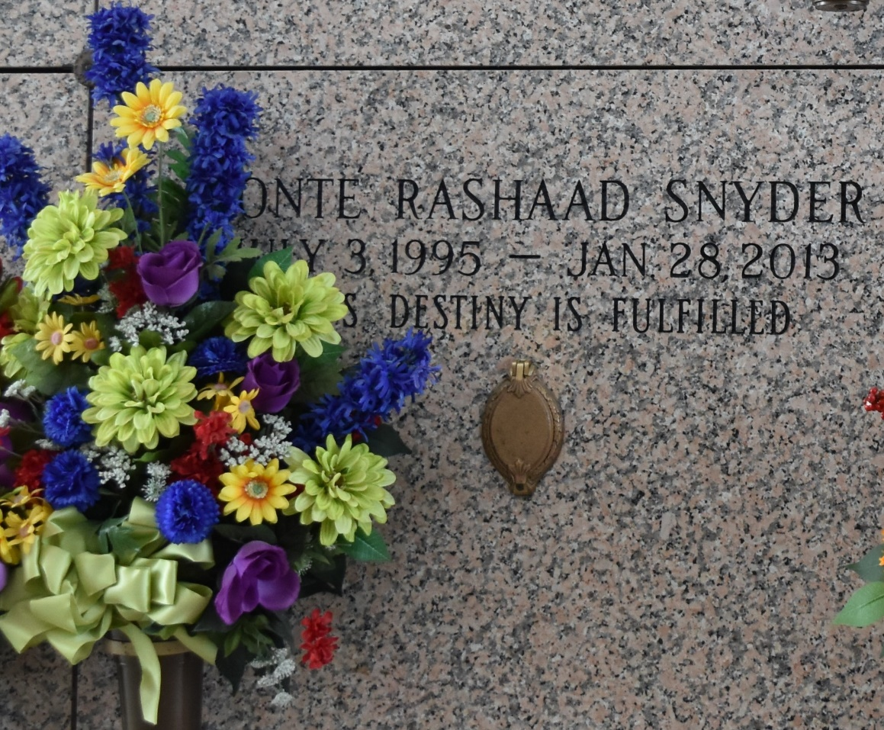

Donte Rashaad Snyder at the age of 17 yrs., departed this earthly life and entered into eternal rest on Monday, January 28, 2013 at Children's Hospital of New Orleans, LA. Beloved son of Indra Gomez Snyder and Larry Snyder Jr. Loving brother of Dario Gomez, Larry "Trai", Jajuan and Allarria Snyder. Grandson of Linda and Oscar Gomez of LaPlace, LA. And Larry Snyder, Sr. of LaPlace, LA and Miranda Snyder of Reserve, LA. Also survived by aunts, other relatives and friends. He was a student at East St. John High School and a resident of LaPlace, LA.
Pastors, officers, and members of 1st Baptist Church of Vacherie, LA. Employees of Ochsner Health System, Cargill, East St. John High School and All neighboring churches are invited to attend the funeral services on Saturday, February 2, 2013 at 12:00 Noon at the First Baptist Church of Vacherie, 1244 Magnolia Hts. Vacherie, LA. Rev. Johnnie Magee officiating. Interment in St. John Memorial Gardens of LaPlace, LA Bardell's Mortuary of Mt. Airy, LA in Charge information (985)535-6837.

The Times-Picayune, New Orleans, Louisiana
January 31-February 1, 2013

