Larry Michael Snyder Sr.
January 7, 1947 – April 19, 2022
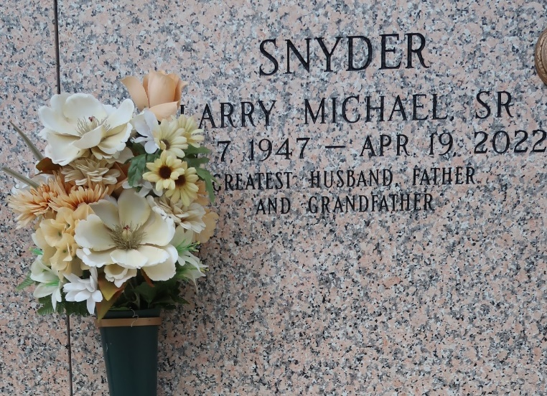

Larry Michael Snyder, Sr. of Laplace, LA, a former Councilman for St. John the Baptist Parish District 6 passed away peacefully at East Jefferson General Hospital in Metairie, LA on Tuesday, April 19, 2022, surrounded by his family.
Son of the late Rev. Peter Snyder, Sr., and Irene (Pauline) Snyder. Husband of Audrey Taylor Snyder; father of Kecia Washington, Cheryl 'Pam'Placide, Michelle Clay, Trina and Larry Snyder, Jr., DiaShiki Snyder-Brown, and Jovon Snyder; Larry is also survived by 5 stepchildren, 18 grandchildren, 22 step-grandchildren, 30 great-grandchildren, 4 great-greatgrandchildren, and a host of nieces, nephews, cousins, and friends.
A Memorial Service will be held on Friday, April 29, 2022, Bethlehem Baptist Church, 147 E 20th Street, Reserve, LA at 6:00p.m. with viewing beginning at 5:00 p.m. Home Going Celebration of Life will be held Saturday, April 30, 2022, at 11:00 a.m. at St. Joan of Arc Catholic Church, 529 W 5th St., Laplace, LA 70068. The Reverend Cyril Buyeera Officiating. Viewing will begin at 10:00a.m. Interment at St. John Memorial Gardens LaPlace, La. Due to CDC (Covid-19) restrictions seating may be limited, MASK is required. Professional Services entrusted to the Caring Staff of Hobson Brown Funeral Home, 134 Daisy St., Garyville, La 70051, 985-535-2516.

The Times-Picayune, New Orleans, Louisiana
April 27-30, 2022

