Lucille (Zeringue) Specht
October 3, 1915 – August 29, 2003
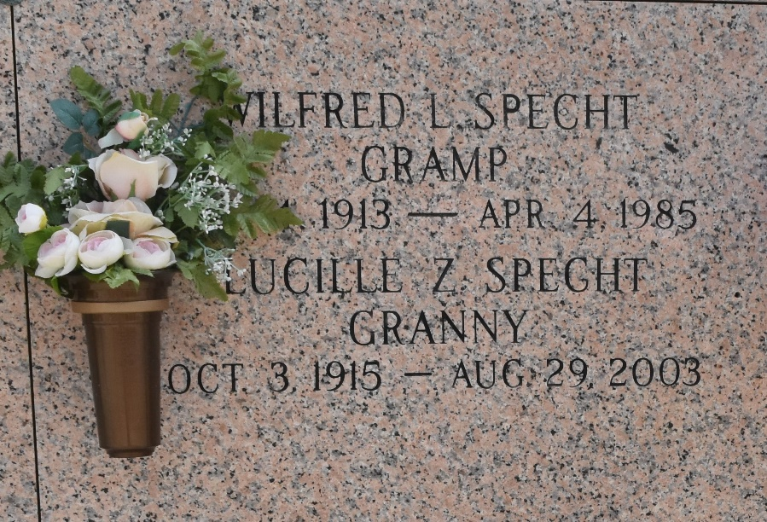

Lucille Zeringue Specht on Friday, August 29, 2003 at 5:17 P.M. Beloved wife of the late Wilfred ''Buck'' Specht, Sr. Mother of Verle S. Loving and Wilfred ''Sonny'' Specht Jr. Daughter of the late Rene' and Jeanne Waguespack Zeringue. Sister of the late Dorothy Z. Richard, Claude and Nolan Zeringue. Mother-in-law of Bob Loving and Laura Specht. Grandmother of Bobby, Rene' and Randy Loving, Mark and Brad Specht. Also survived by 13 great-grandchildren. Age 87 years, a native of Algiers, La. and longtime resident of Lafourche Parish and for the past 48 years of LaPlace, La.

Relatives and friends of the family are invited to attend services. Visitation at Ascension of Our Lord Church, 1809 Greenwood Drive, LaPlace, LA on Monday, September 1, 2003 from 9:30 AM followed by a Mass of Christian Burial at 11:00 AM. Burial in St. John Memorial Garden, LaPlace, LA. In lieu of flowers, Mass is preferred. Arrangements by Millet-Guidry Funeral Home, LaPlace, LA.

The Times-Picayune, New Orleans, Louisiana
August 31 – September 1, 2003

