Julian Michael Spruell
October 18, 1948 – January 31, 2021

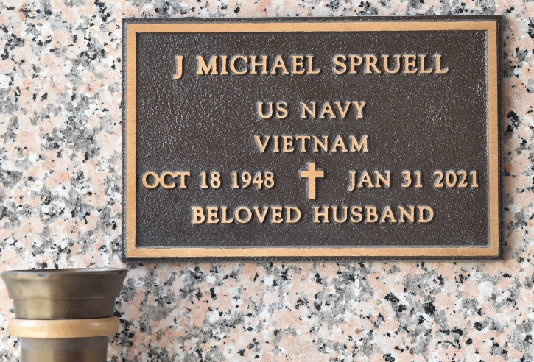

Julian Michael Spruell, a native and resident of LaPlace, LA, passed away on January 31, 2021 at the age of 72. Mike was a Navy veteran who was very proud to have served his country. He always greeted his doctor with a thumbs up or salute.
He is survived by his wife, Sheila Spruell; his stepdaughter, Michele Boudreaux; his stepson, James Falterman; and his granddaughter, Bentley Boudreaux.
He is preceded in death by his parents, Julian Spruell and Clara Burnett Spruell; and his sisters, Ellen and Betty.
A graveside service will be held at St. John Memorial Gardens Cemetery in Laplace, LA on Friday, February 5, 2021 at 11:00 AM.

Rose Lynn Funeral Home, Lutcher, Louisiana

