Charles Joseph St. Germain
February 3, 1934 – June 1, 2017
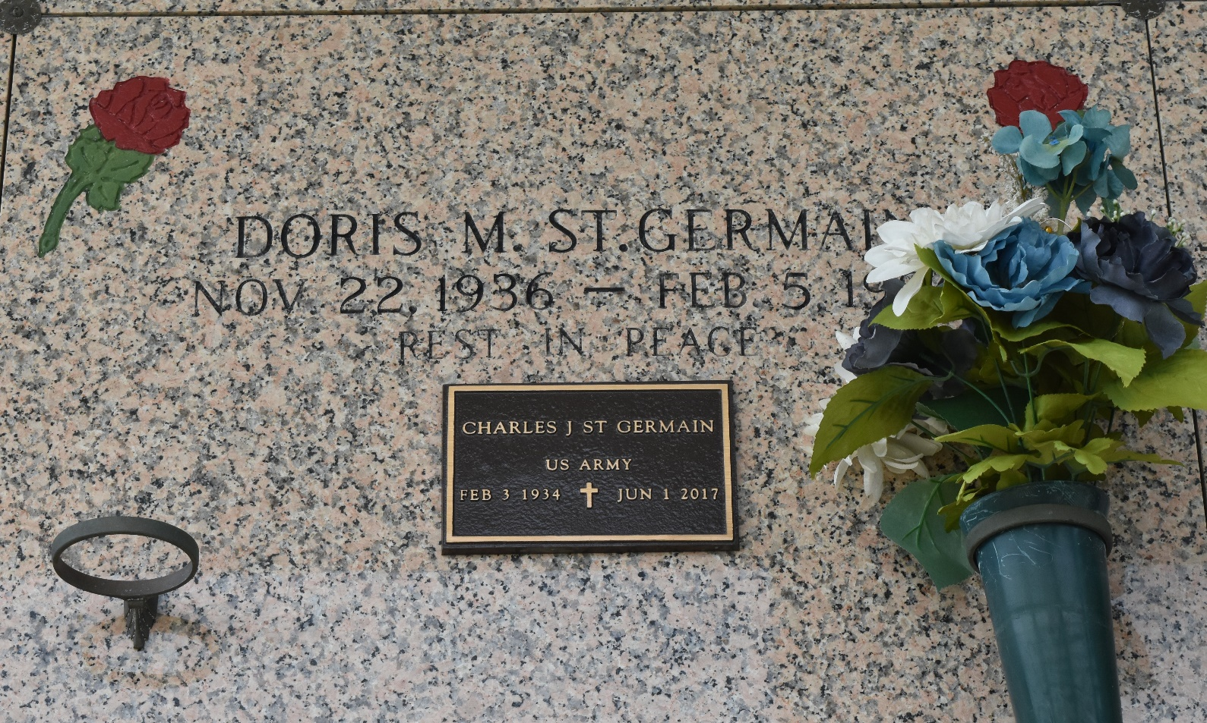

Charles Joseph St. Germain passed away on Thursday, June 1, 2017 at the age of 83. A native of Napoleonville, LA and a resident of LaPlace, LA. Beloved husband of the late Doris Mae Clement St. Germain. Father of Charles Michael St. Germain (Kimberly Steele) and Debra Ann St. Germain. Son of the late Esma Thibodeaux St. Germain and Leonie J. St. Germain. Brother of L.J. St. Germain and the late Roland Paul St. Germain, Leroy Joseph St. Germain, Lucy Mae St. Germain (the late Keating) and Ridley Joseph St. Germain. Grandfather of Brandon Paul St. Germain, Jennifer Lynn St. Germain, Justin Anthony St. Germain and Keith Joseph Pfister. Great-grandfather of Katelyn Nicole Ory. Also survived by many nieces and nephews.
Relatives and friends are invited to attend the visitation at Millet-Guidry Funeral Home, 2806 W. Airline Hwy, LaPlace on Tuesday June 6, 2017 from 9:00 a.m. until 11:00 p.m. followed by a Funeral Mass at St. Joan of Arc Catholic Church, 529 W 5th Street, LaPlace at 11:30 a.m. Interment in St. John Memorial Gardens Cemetery. To view and sign the online guest book, please visit www.milletguidry.com.

New Orleans Advocate, Louisiana
June 3-6, 2017

