Leroy J. St. Germain
November 1, 1924 – September 23, 2013
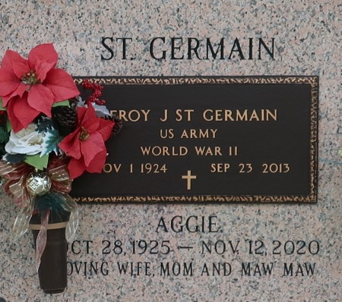

Leroy J. St. Germain was born in Plattenville, LA on November 1, 1924. He entered Heaven's gates on September 23, 2013. Devoted husband, loving father, and adoring grandfather, Leroy had an unwavering faith in God inspiring all to serve the Lord. Leroy served in the Army in WW II.
Leroy was predeceased by his parents Leonie and Esma St. Germain, by his son JD, and by his two brothers, Roland and Ridley St. Germain and his sister, Lucy Mae Keating.
Leroy is survived by his best friend and wife Aggie St. Germain and his sons Herman Middlebrook (Rose) and Wayne Middlebrook (Mona). He is also survived by his brothers, LJ St. Germain (Jeanne') and Charles St. Germain; grandchildren, Michele Middlebrook Harris (Adrian), Michael Middlebrook, Hayden Middlebrook (Michelle), Wesley Middlebrook (Tykie), Curtis Boudreaux (Brandy), and Mandy Middlebrook-Lovett (Michael); and great-grandchildren, Ellen Harris, Megan Harris, Chandler Middlebrook, Joey Brue, Abby Harris, Cassidy Middlebrook, Rachel Middlebrook, Nicholas Middlebrook, Rhett Boudreaux, Patrick Brue, Kieley Middlebrook, and Rowan Lovett.
Funeral services will be held on Wednesday, September 25, 2013 at Millet Guidry Funeral Home, 2806 W. Airline Hwy in Laplace, La. Visitation will be on Wednesday morning at 10:00AM until 12:00Noon, followed by Religious services in the funeral home chapel. Burial in St. John Memorial Garden Cemetery. In lieu of flowers, the family is asking to send donations to St. Jude Children's Research Hospital.

New Orleans Advocate, Louisiana
September 23-24, 2013

