Della (Hebert) St. Martin
January 14, 1949 – January 29, 2021

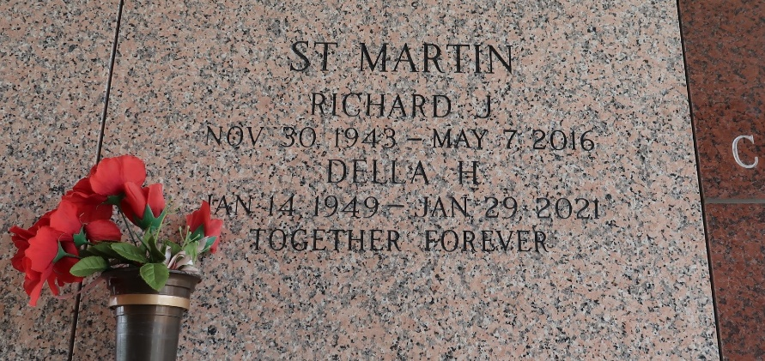

Della H. St. Martin was a lifelong Louisiana resident until she moved to Florida in 2016. She then became resident and an unofficial member of the VFW 4412 Auxiliary in Hudson Florida where she volunteered many hours but gained many loyal and valued friends. She was fondly known as the make-shift "Motherly Figure" to many nieces and nephews, and to the old neighborhood kids.
On Friday, January 29, 2021, Della received her heavenly Halo, Gown, and Wings to wear to her final resting place beside her Husband (Richard) and our Lord Savior Jesus Christ. Leaving behind many cherished memories of her with her children: Donald J. St. Martin, Sr. (Joyce), Sherry S. Scott (Larry), and Twenette M. Keating (Jeffrey); her grandchildren: Alicia, DJ (Donald Jr.) Taylor, Jeffrey II, Richard and Jessie; her great grandchildren: Londyn, Karleigh and Madyson. Also leaving many cherished memories of her with her brothers and sisters: Michael, Milton (Sarah), Roual (Biddy), Ralph, Patricia, and Julie (Paul), and survived by many other nieces and nephews and Leizanne (DJ's mother).
She is preceded in death by her husband Richard St. Martin, grandson Donnie Gene King, parents Lillian Vicknair and Milton Hebert and her sisters Laura, Linda and Audry. She will be sorely missed and beloved by many.
The visitation will be held at Millet-Guidry Funeral Home, 2806 W. Airline Hwy, LaPlace on Saturday February 6, 2021 from 12pm - 1pm with a brief church service to immediately follow led by Deacon Garland. The burial will be held in St. John Memorial Gardens Cemetery.
Millet-Guidry Funeral Home, LaPlace, Louisiana
January 31, 2021

