Enola Marie (Kugler) St. Martin
March 25, 1929 – October 11, 2010

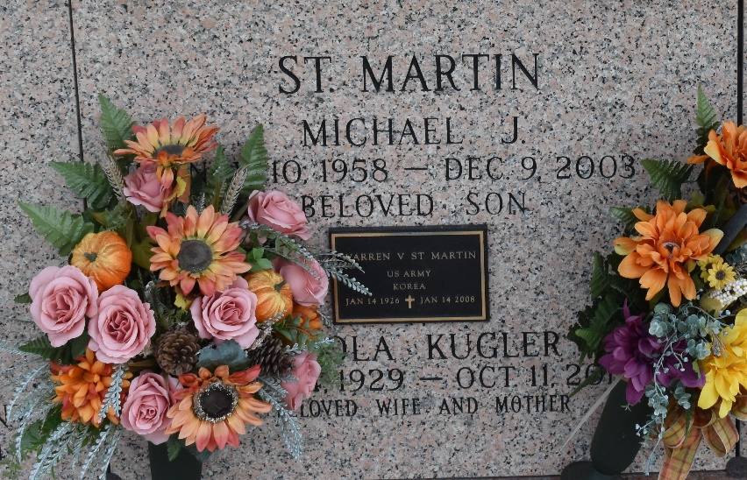

On Saturday, October 11, 2014, Heaven embraced another Angel, Enola Kugler St. Martin, who went to be with the Lord at the age of 85. She was a native and lifelong resident of St. John Parish. Beloved wife of the late Warren Vincent St. Martin, Sr. Loving mother of Denise Brady (Pop Top), Andrew St. Martin (Charlene), Warren St. Martin, Jr. (Beryl), Anna Henry (Roy), Patricia St. Martin, Paul St. Martin (Tish), Daniel St. Martin (Gaylyn), Lee St. Martin and the late Michael J. St. Martin. Sister of Rita Sikes. Also survived by 23 grandchildren and step grandchildren, 34 great grandchildren and step great grandchildren and numerous nieces and nephews.
Relatives and friends are invited to attend the Visitation at Millet-Guidry Funeral Home, 2806 W. Airline Hwy, LaPlace, on Wednesday, October 15, 2014, from 9:00 a.m. until 11:00 a.m. followed by the Funeral Mass at St. Joan of Arc Catholic Church, 529 West 5th St., LaPlace at 11:30 a.m. Interment in St. John Memorial Gardens Cemetery.

The New Orleans Advocate, Louisiana
Oct. 14 to Oct. 16, 2014

