Marjorie (Flanagan) St. Martin

July 23, 1926 – January 27, 2011

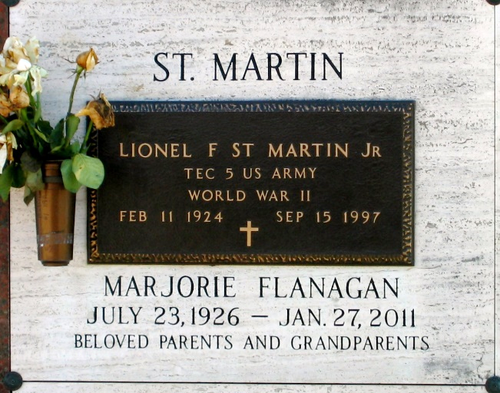

Photo by Bobby

Marjorie Flanagan St. Martin passed away on Thursday, January 27, 2011. Beloved wife of the late Lionel St. Martin, Jr. Mother of Michelle St. Martin, Debbie Sigler, Mandy Vicknair, Lionel III and Larry St. Martin. Also survived by 11 grandchildren and 3 great-grandchildren. Sister of Lorraine Flanagan, Larry Flanagan, the late Azema Hoskins, T.J. Flanagan and Claire Hardy. Age 84 years. A native of New Orleans, LA and a resident of LaPlace, LA.

Relatives and friends are invited to attend services. Visitation at Millet-Guidry Funeral Home, 2806 W. Airline Hwy., LaPlace, LA on Sunday, January 30, 2011 from 5:00 p.m. until 9:00 p.m. and on Monday at Ascension of Our Lord Catholic Church, 1809 Greenwood, LaPlace, LA from 10:00 a.m. until 11:00 a.m. followed by a Mass at 11:00 a.m. Burial in St. John Memorial Gardens Cemetery LaPlace, LA.

The Times-Picayune, New Orleans, Louisiana

Jan. 30, 2011