Mary (Duhe) St. Martin
February 18, 1952 – April 12, 2013

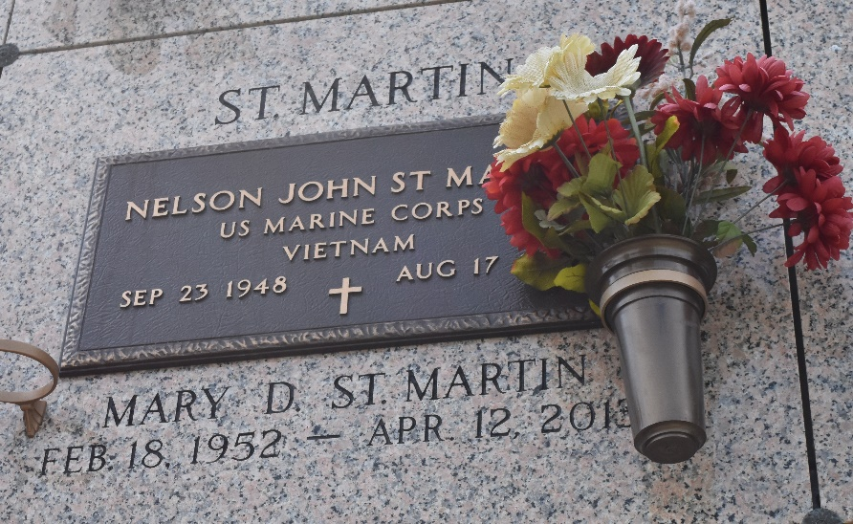

Mary Duhe St. Martin passed away on Friday April 12, 2013. Beloved wife of the late Nelson Johnny St. Martin. Mother of Juanita Bacas (Benny), Joseph St. Martin, Jennifer Thiele (Jerry) and John St. Martin. Grandmother of Jace St. Martin and Ashlynn Thiele. Daughter of Nellie Duhe and the late Freddie Duhe. Also survived by sisters and brothers. Age 61. A native of Reserve and a resident of LaPlace.

Relatives and friends are invited to attend services. Visitation at St. Joan of Arc Catholic Church, LaPlace, La on Tuesday April 16, 2013 from 9:30am to 11:00am, followed by Mass at 11:00am. Burial in St. John Memorial Gardens, LaPlace, LA. Arrangements by Millet-Guidry Funeral Home, LaPlace, LA.
The Times-Picayune, New Orleans, Louisiana
April 12-14, 2013

