Nelson John St. Martin
September 23, 1948 – August 17, 2007

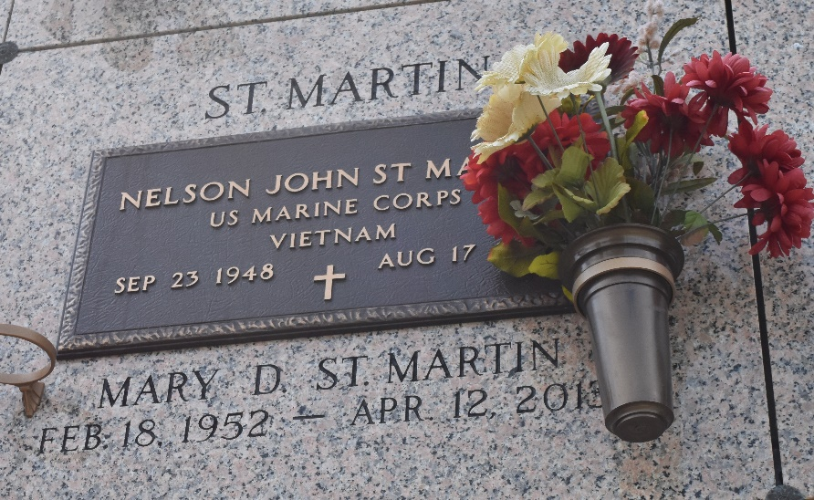

Nelson Johnny St. Martin, on Friday, August 17, 2007 at 7:20 am. Beloved husband of Mary Duhe St. Martin. Father and father-in-law of Juanita and Benny Bacas, Joseph St. Martin, Jennifer and Jerry Thiele and John St. Martin. Grandfather of Jace St. Martin. Son of Mary St. Martin and the late Nelson St. Martin. Brother of Lynn and Allen St. Martin, Mary Frances Breaud and Carol Ann St. Martin. Also survived by nieces and nephews.

He was a member of The U.S. Marine Corps serving during The Vietnam Conflict. Age 58. A native and resident of Laplace.

Relatives and friends of the family, also St. John The Baptist Sheriff Dept., are invited to attend services. Visitation at St. Joan of Arc Catholic Church, Laplace, on Tuesday, August 21, 2007 from 8:30 am to 10 am. followed by religious services at the church at 10 am. Burial in St. John Memorial Gardens, Laplace. Arrangements by Millet-Guidry Funeral Home, Laplace.
The Times-Picayune, New Orleans, Louisiana
August 18, 2007

