Richard J. St. Martin

November 30, 1943 – May 7, 2016

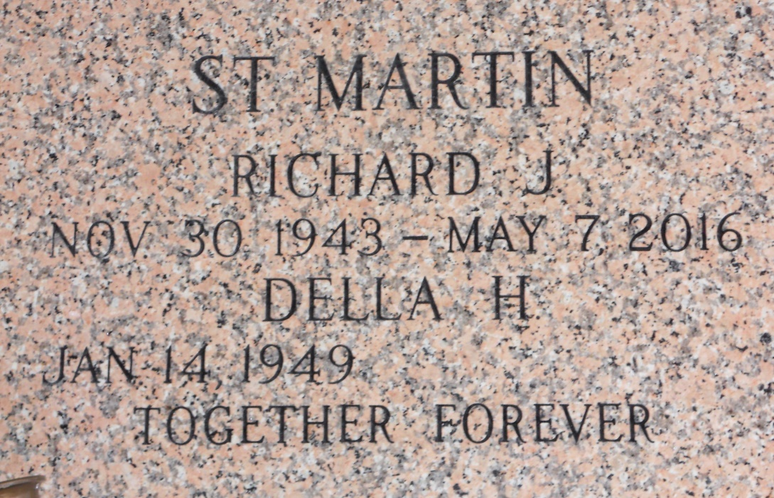

Photo by Team T Lo

Richard J. St. Martin, 72, on Saturday, May 7, 2016, received his heavenly wings with his family gathered by his side. St. Martin was born Nov. 30, 1943.  
 Left to cherish his memories are his wife of 51 years, Della H. St. Martin; his children, Donald J. St. Martin, Sherry S. Scott (Larry) and Twenette Keating (Jeffrey); grandchildren Alicia Lee Dickinson, Donald J. St. Martin Jr., Taylor M St. Amant, Jeffrey M. Keating II, Richard J. St. Martin and the late Donnie Gene; great grandchildren Londyn Desormo, Karleigh Lilly and Madyson Lilly; brothers Lloyd J. St. Martin Jr., Dave St. Martin; and sisters Linda Hume and Robin Jennings. His is also survived by nieces, nephews and other relatives.  
 St. Martin was preceded in death by his parents, Lloyd J. St. Martin and Frances O. St. Martin. He will be sorely missed and loved by many.  
 Visitation will be held at Millet-Guidry Funeral Home, 2806 W. Airline Highway in LaPlace on Thursday, May 12 from noon to 2 p.m. The Funeral Service will be held at 2 p.m. Interment is in St. John Memorial Gardens Cemetery.  
 To view or sign the online guest book please visit [www.milletguidry.com](http://www.milletguidry.com/).

L'Observateur (La Place, LA) - Monday, May 9, 2016

Contributed by Jane Edson