Frances (Miano) St. Pierre
April 5, 1929 – December 26, 2006

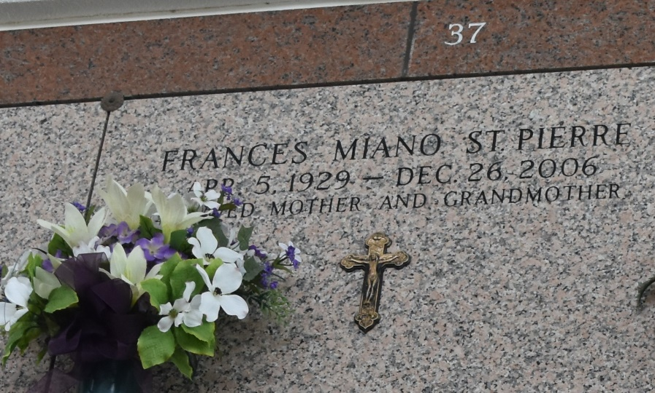

Frances Miano St. Pierre, on Tuesday, December 26, 2006 at 6:15 a.m. Beloved mother and mother-in-law of Darryl and Gail, Kenneth and Tanya and Leroy, Jr. and Erin St. Pierre, Sandra and Percy Vicknair, Arlene and Rusty Martin and Sheryl and Raymond Jackson. Daughter of the late Paul and Anna Tramonte Miano. Sister and sister-in-law of Samuel P. and Dorothy Miano. Grandmother of Matthew, Jacqueline, Lindsey, Ryan, Jacob and Julien St. Pierre, Paul Kraemer, Brandy Ross, Brett and Julie Jackson and Austin and Ally Martin. Mother-in-law of the late Calvin Kraemer. She was a longtime employee of Landmark Land. Age 77. A native of Garyville and a resident of Laplace for the past 5 years.
Relatives and friends of the family, also St. Hubert Ladies Altar Society, Garyville VFW Ladies Auxiliary Post 8167, AARP and C.A.P. are invited to attend services. Visitation at St. Hubert Catholic Church, Garyville, LA. on Thursday, December 28, 2006 from 9 am to 11 am followed by religious services at the church at 11 am. Burial in St. John Memorial Gardens Cemetery, Laplace. Arrangements by Millet-Guidry Funeral Home, Laplace.

The Times-Picayune, New Orleans, Louisiana
December 27, 2006

