Leroy J. St. Pierre Sr.
January 26, 1927 – November 11, 2003

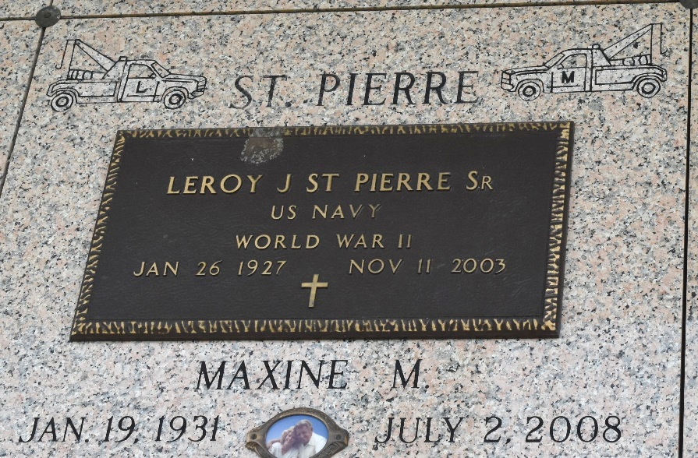

Leroy J. St. Pierre, Sr. on Tuesday, November 11, 2003 at 4:32 am. Beloved husband of Maxine St. Pierre. Father of Darryl, Kenneth, and Leroy St. Pierre, Jr., Sandra Vicknair, Arlene Martin and Sheryl Jackson. Step father of Vickie Brehm, Jerald and Richard Barnhill. Son of the late Clement and Winnie St. Pierre. Brother of Elzey, Wallace and Allen St. Pierre, the late Lois and Earl St. Pierre, and Dolores James. Also survived by 11 grandchildren and 2 step grandchildren and 2 step great grandchildren. He was a member of VFW Post 8167 Garyville, LA. Age 76 years. A native of Paulina, LA and a resident of Laplace for the past 30 years.
Relatives and friends of the family are invited to attend the funeral services. Visitation at Millet Guidry Funeral Home, 2806 W. Airline Hwy., Laplace, on Thursday, November 13, 2003 from 8:30 am until 10:00 am. Followed by religious services in the funeral home chapel at 10:00 am. Burial in St. John Memorial Gardens, Laplace, LA. In lieu of flowers donations to the American Cancer Society, preferred.

The Times-Picayune, New Orleans, Louisiana
November 12, 2003

