Joseph Adam St. Romain
May 12, 1931 – April 18, 2011

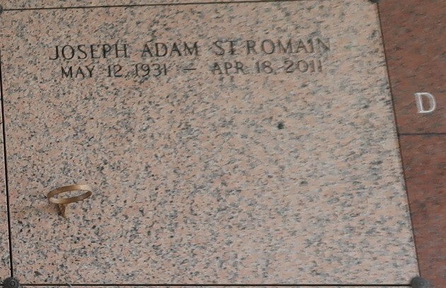

Joseph Adam St. Romain passed away Monday, April 18 at East Jefferson Memorial Hospital. Adam was born in Oscar, LA on May 12, 1931 to William and Viletta St. Romain. Adam had ten siblings, three brothers and seven sisters and is survived by sisters Marie Clare Morgan and Ethel St. Romain. Adam had three children, Christopher, Christina and Steven and is survived by Christopher and Christina. He is also survived by five grandchildren and seven great-grandchildren.
Adam will be laid to rest at St. John Memorial Gardens in LaPlace, LA.

The Times-Picayune, New Orleans, Louisiana
April 20, 2011

