Dudley Anthony Stadler Jr.
August 6, 1927 – August 2, 2005
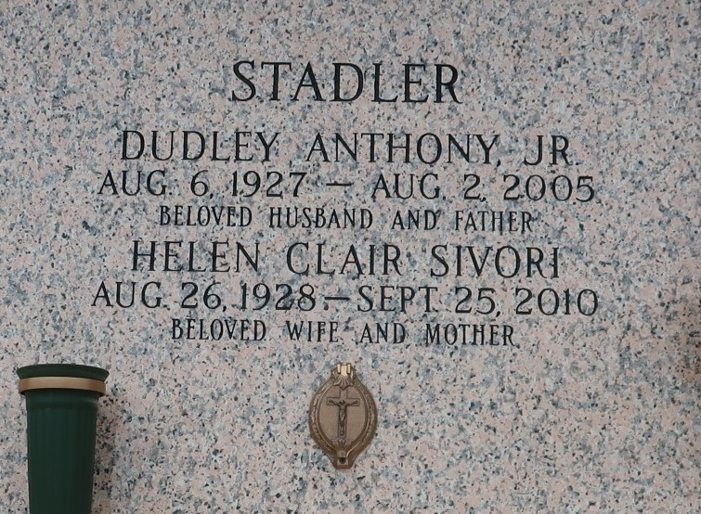

Dudley A. Stadler, Jr. on Tuesday August 2, 2005 at 10:58 a.m. Beloved husband of Clair Sivori Stadler. Father of Christina Hull, Sybil Brenner, Dudley A. Stadler, III, Lisa Stagno and Gretchen de Gruy. Also survived by 11 grandchildren and 2 great grandchildren. Son of the late Dudley and Rita Stadler. Brother of Beverley Stadler. Age 77 years. A native of New Orleans, LA and a resident of LaPlace, LA for the past 40 years.

Relatives and friends of the family are invited to attend services. Visitation at MILLET-GUIDRY FUNERAL HOME, 2806 W. Airline Hwy, Laplace on Wednesday, August 3, 2005 from 5:00 p.m. to 800 p.m. and on Thursday from 8:00 a.m. to 10:00 a.m. Followed by religious services at the funeral home chapel at 10:00 a.m. Burial in St. John Memorial Gardens Cemetery, Laplace. In lieu of flowers, donations preferred to your favorite charity.

The Times-Picayune, New Orleans, Louisiana
August 3, 2005

