Marion R. (Wallace) Steib
October 31, 1944 – January 20, 2017
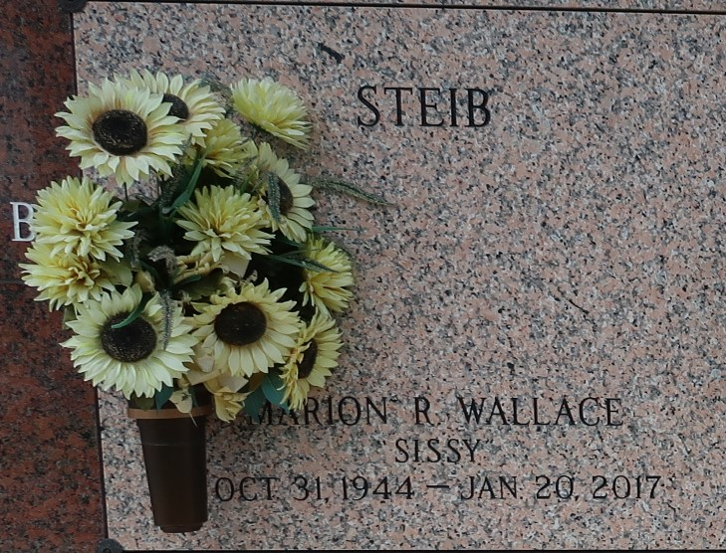

Marion R. Steib "Sissy" on Friday, January 20, 2017 at her home in Reserve, LA. Daughter of the late Lillie and Thomas Wallace, Sr. Stepdaughter of Henry McClain, Sr. Wife of Michael Steib, Sr. Mother of Michael, Jr. and Michele Steib. Sister of Gloria Dean Wallace, Herman Wallace (Nettie), Wilfred Wallace, Johnel McClain (Dale), Marcel McClain, Gae Davis (Howard), Janice Mitchell (Wilfred), the late Thomas Wallace, Jr. and Richard Wallace. Stepsister of Henry McClain, Jr., Yvonne Johnson and the late Herman McClain. Sister-in-law of Ceola and Caroyn Wallace and Lucille McClain. Grandmother of Brittany Michele Steib. Also survived by a host of nieces, nephews, cousins, other relatives and friends. Age 72 years. A native and a resident of Reserve, LA.
Relatives and friends of the family, also pastors, officers and members of First Community Antioch Baptist Church, Beech Grove Baptist Church, Reserve, LA, priest and parishioners of Our Lady of Grace Catholic Church and all neighboring churches are invited to attend the Funeral Service at First Community Antioch Baptist Church, 10860 Highway 3125, Gramercy, LA on Saturday, January 28, 2017 at 11:00 AM. Rev. Ferdinand Gaines, Jr., Host Pastor, Officiating Rev. Wesley Anderson, Pastor of Beech Grove Baptist Church. Interment St. John Memorial Garden Cemetery, LaPlace, LA. Visitation at the above named church from 9:00 AM until Service Time ONLY SERVICED BY ROBOTTOM.

The Times-Picayune, New Orleans, Louisiana
Jan. 24 to Jan. 27, 2017

Treasures of Life Funeral Services, Gramercy, Louisiana

