Helen L. (Grigsby) Stelz
January 2, 1934 – January 14, 2009
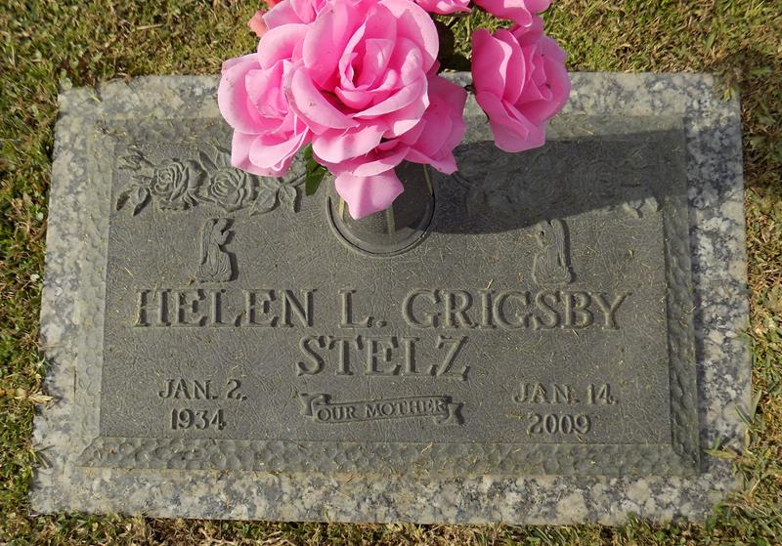

Helen L. Grigsby Stelz passed away on January 14, 2009, age 75, at Oschner Kenner Hospital. She was born on January 2, 1934 to the late Burley Grigsby and Kathleen Sadie Revelle Grigsby and was a resident of New Orleans Kenner most of her life. She was a graduate of Elanore McMain High School and a retired employee of Wal-Mart Garden Center where her love of horticulture earned her concurrent yearly awards for care, presentation and sales. She is survived by her two children, Pamela J. Stelz Schwartz and H. G. Chip Stelz, also by Laurie Palestina Nassar, her daughter in spirit. Relatives and friends of the family are invited to attend the viewing and service at Leitz-Eagan Funeral Home, 4747 Veterans Blvd., Metairie, LA., on Wednesday, January 21, 2009 at 1:00pm. Interment in St. John's Memorial Gardens, Laplace, LA will follow the service. Visitation from 11:00am until 1:00pm.
The Times-Picayune, New Orleans, Louisiana
Tuesday, January 20, 2009

