Carl A. Stemley
September 15, 1964 – June 8, 2020
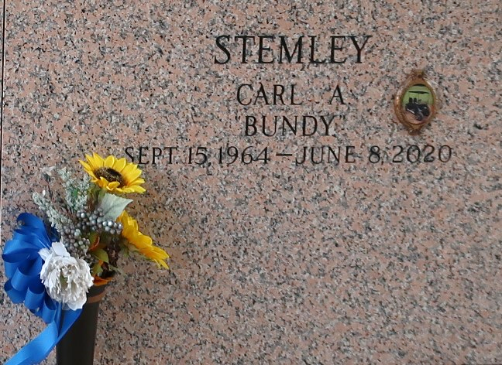

Carl "Bundy" Stemley entered into eternal rest on Monday June 8, 2020 in Laplace, La. Age 55. Son of the late Delores Stemley. Brother of Kimberly Stemley. Father of Jayne Stemley. Nephew of Florence Jessie, Evelyn, Lillie Mae, Pearl, Barbara, Leroy, Raymond and Charles Stemley, Sr. Carl is survived by a host of other relatives and friends.

Celebration service will be held on Saturday, June 13, 2020 at Mt. Calvary Baptist Church, 127 W 3rd St. LaPlace, LA 70068 at 11:00am. Viewing from 9:00am – 11:00am. Rev. Freddie Howard Pastor, Officiating. Interment St. John Memorial Gardens, LaPlace, La. PLEASE WEAR MASK. Professional Services entrusted to the caring staff Hobson Brown Funeral Home, 134 Daisy St., Garyville, La 70051, (985) 535-2516.

The Times-Picayune, New Orleans, Louisiana
June 11-13, 2020

