Herbert Stemley Jr.
March 2, 1944 – September 18, 2009
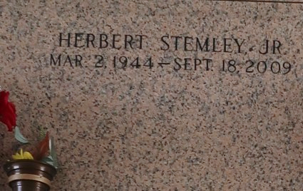

Herbert Stemley, Jr., (Herb/Nink) Stemley, Herbert Jr., born to Lillie Variste Stemley, and the late Herbert Stemley, Sr., March 2, 1944. On Friday morning, September 18, 2009 at 3:55 a.m. at Terrebonne General Hospital, Houma, La., Herbert Stemley, Jr., transitioned to his heavenly home.
The brother of Bernadine Johnson of Baton Rouge, La., Pearl Stemley of Reserve, La., Charles, Morris, Raymond, Lillie Mae, Evelyn, Florence, Leroy, and Barbara Ann Stemley of LaPlace, La., the late David, Deloris and Earl Stemley. Brother-in-law of Jimmie Jessie, Katherine, Ethel, and Geneva Stemley of LaPlace, La. A retired Steel Rod Buster, and Construction worker. A native and resident of LaPlace, La.,
Pastor, officers, and members of Mt. Calvary Baptist Church, all neighboring churches, relatives and friends are invited to attend the Funeral Service on Saturday, September 26, 2009 at 11:00 a.m. at Mt. Calvary Baptist Church, 123 West Third Street, LaPlace, La 70068. Rev. Dr. Freddie L. Howard Officiating. Visitation, Saturday morning, September 26, 2009 from 9:00 a.m. until 11:00 a.m. Interment follows at St. John Memorial Garden Cemetery, West Airline Highway, LaPlace, La. Professional Service Entrusted to Hobson Brown Funeral Home, 134 Daisy St., Garyville, La. (985) 535-2516.

The Times-Picayune, New Orleans, Louisiana
September 25, 2009

