Lillie (Variste) Stemley
October 28, 1918 – March 29, 2014
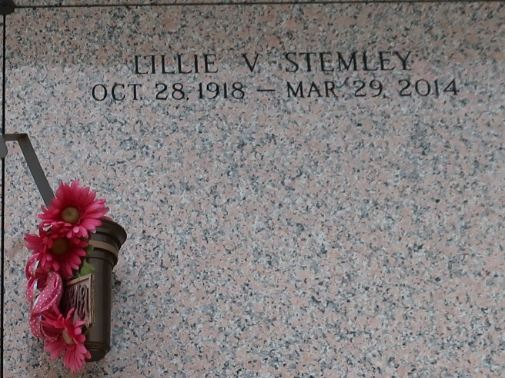

Lillie V. Stemley, age 95, departed this on March 29, 2014. Daughter of the late Morris Variste and Evelina Rogers Bazile. Wife of the late Herbert Stemley Sr. Mother of Pearl, Charles Sr, Morris, Raymond, Lillie Mae, Evelyn, Leroy and Barbara Stemley, Florence Jessie and the late David, Earl, Deloris and Herbert Stemley Jr. Also survived by a host of grandchildren, great grandchildren, great great grandchildren, other relatives and friends.
Funeral Services will be held on Saturday, April 5, 2014 at Providence B. C.# 1 228 Pine St., Laplace, La. at 11:00am Rev. Willie Smith Officiating Visitation will begin at 9:00am until service time. Interment in St. John Memorial Laplace, La. Services Entrusted to Hobson Brown Funeral home 985-535-2516.

The Times-Picayune, New Orleans, Louisiana
Apr. 3 to Apr. 4, 2014

