Martine R. Stemley
October 26, 1981 – June 30, 2014

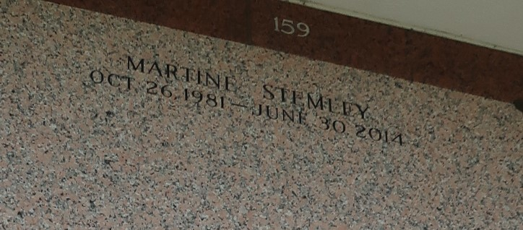

Martine R Stemley, age 32, departed this life on Monday, June 30, 2014. Daughter of Sandra S Chopin, and the late Mark Lee Mitchell, sister of Renika Banks, Dequincy, Darion Stemley and Teric Wilson granddaughter of Charles Stemley Sr., niece of Charlene Young, Charles Jr, Bernell, Dwayne, and Michael Stemley. Also survived by nieces, nephew godchildren, other relatives, and friends.
Pastors, officers, and member of Raising Star Baptist Church of LaPlace, LA and all neighboring churches, St. John the Baptist Parish School Board, H & R Block are invited to attend the home going celebration on Tuesday, July 8, 2014, at 11:00 a.m. at Raising Stars Baptist Church 620 Cardinal Street, LaPlace, LA, Pastor Donald August officiating. Visitation will be at 9:00 a.m. until service time. (ONLY). Interment in St. John Memorial Cemetery Laplace, LA, Hobson Brown Funeral Home, Inc Grayville, LA.
The Times-Picayune, New Orleans, Louisiana
Jul. 3 to Jul. 6, 2014

