Morris Byrd Stemley
March 9, 1945 – December 15, 2014

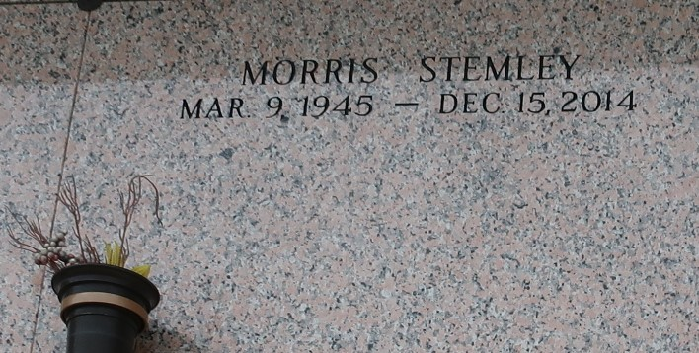

Morris Byrd Stemley departed this life on Monday, December 15, 2014. Son of the late Herbert and Lillie Stemley. Brother of Barbara, Lillie Mae, Pearl, Evelyn, Charles, Raymond, and Leroy Stemley, Bernadine Johnson and Florence Jessie. Also survived by a host of nieces, nephews, other relatives.

Relatives and friends, employees of Hilton Inn of Kenner, La. are invited to attend the funeral service on Saturday, December 20, 2014 at 11:00am from Mt. Calvary B.C., 123 W. 3rd St., Laplace, La. Rev. Freddie Howard Officiating. Visitation at church from 9am until service time. Interment in St. John Memorial Laplace, La. Services Entrusted to Hobson Brown Funeral Home 134 Daisy St., Garyville, La 70051 985-535-2516.

The Times-Picayune, New Orleans, Louisiana
December 17-19, 2014

