Alfred Sterling Sr.
September 15, 1964 – June 8, 2020
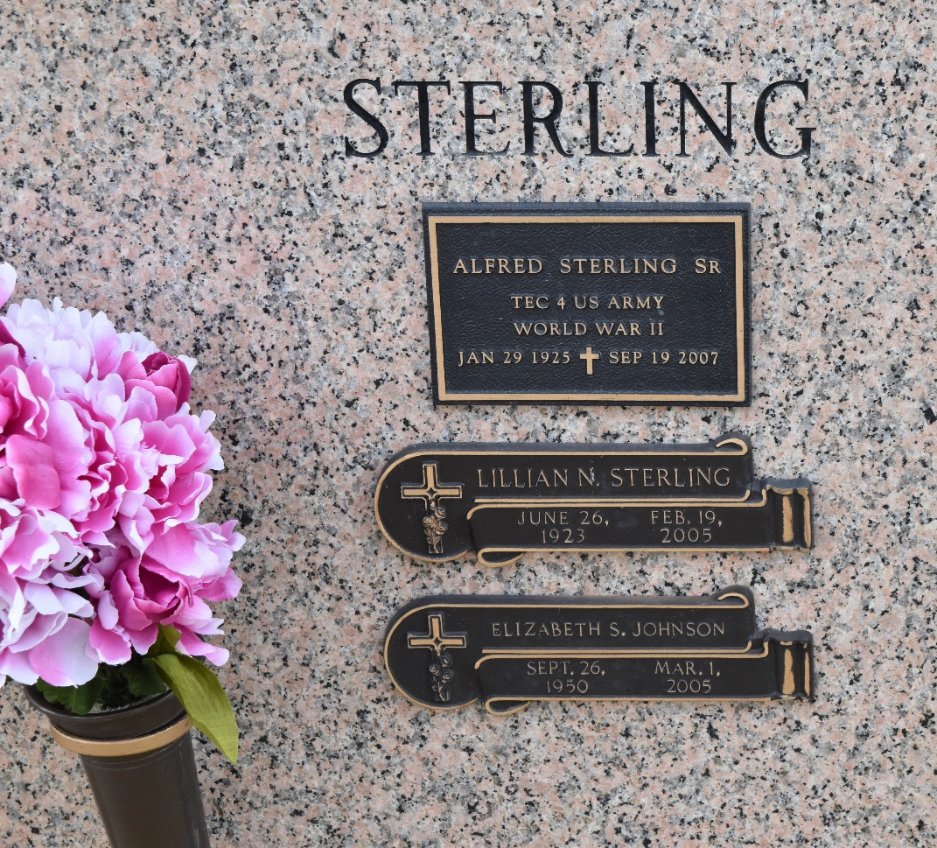

Alfred Sterling, Sr. passed away on Wednesday, September 19, 2007.
Mr. Sterling leaves to cherish his memory his children, a brother, 2 sisters-in-law, a son-in-law, a daughter-in-law, his grandchildren, great-grandchildren, 1 godchild, other relatives and friends.
He was preceded in death by his wife, Lillian Noel Sterling; his parents; a son, a daughter, two sisters and three brothers. Mr. Sterling's family is extremely grateful for all expressions of sympathy and condolences.
Private services will be held. Respect of this request is greatly appreciated. THE BALONEY FUNERAL HOME, L.L.C. 399 Earl Baloney Dr., Garyville, LA 70051 Information: (985) 535-2540 IN CHARGE OF ARRANGEMENTS.

The Times-Picayune, New Orleans, Louisiana
September 23, 2007

