Wesley Stevenson Jr.
November 23, 1947 – March 15, 2012
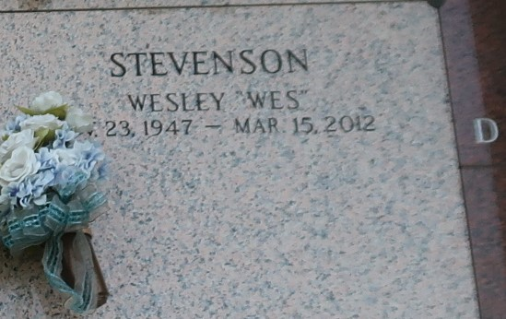

Wesley "Wes" Stevenson, Jr. on Thursday, March 15, 2012 at his home in Reserve, LA. Son of the late Wesley Stevenson, Sr. and Alma Stevenson Ruff. Husband of Marie Cook Stevenson. Father of Tennia Stevenson Williams (Sylvester), Jason Stevenson, Angela Montgomery and Yolanda Montgomery. Brother of Harold Stevenson (Regina) and Donald Stevenson (Bonnie). Brother-in-law of Goldie Wilkens (Clarence), Veronica Bailey (Herman), Lionel Cook (Elsie) and Oscar Cook (Doris). Special brother of Carmella Gordon and Rita Kyles. Devoted friend of John and Marva Smith. Devoted cousin of David Williams (Angela). Also survived by 5 grandchildren, 3 great-grandchildren and a host of nieces, nephews, other relatives and friends. Age 64 years. A native of Chicago, IL and resident of Reserve, LA.
Relatives and friends of the family also pastors, officers and members of Destiny Christian Center and all neighboring churches are invited to attend the funeral at Destiny Christian Center, 612 Main Street, LaPlace, LA on Friday, March 23, 2012 at 11:00 AM. Pastor Steve O. Allen, Officiating. Interment St. John Memorial Gardens Cemetery, LaPlace, LA. Visitation at the above named church from 9:00 AM until service time. SERVICED BY ROBOTTOM.

The Times-Picayune, New Orleans, Louisiana
February 24, 2005

