Linda R. Stillwell
December 7, 1947 – May 23, 2022

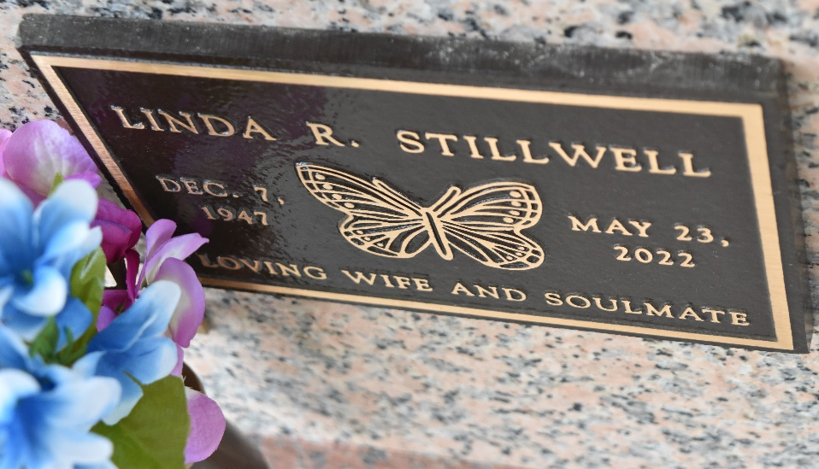

Linda Stillwell passed away on Monday, May 23, 2022 at the age of 74. She was a lifelong resident of LaPlace, LA.
Loving wife of James "Jimmy" Stillwell. Loving mother of James Richard Carter. Daughter of the late Lawrence and Velma Rachall. Sister of Geraldine Stokes and Sherry Abba. Also survived by numerous nieces and nephews.
Relatives and friends are invited to attend the Visitation and Celebration of Life at Millet-Guidry Funeral Home, 2806 W. Airline Hwy., LaPlace on Monday, May 30, 2022. Visitation from 1:00 p.m. to 4:00 p.m. To share memories or condolences, please visit www.milletguidry.com

Obituary published on Legacy.com by Millet-Guidry Funeral Home
May 27, 2022

