TaiJa Ijanae Stokes
February 27, 1989 – May 4, 2008

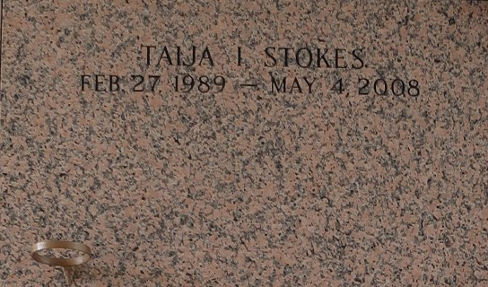

Tai'ja Ijanae' Stokes, age 19, a student, passed away on Sunday, May 4, 2008 in Laplace, La. Daughter of Dorothy Lee Stokes and William Butler. Sister of Sabrina and Grayland Ceaser, Jr., Terry Stokes, Tion Butler and Josh Lee Wilson. Also survived 4 aunts: Deborah King, Katherine Singleton, Vanessa Bowers, and Joyce Washington, 1 uncle, Walter Washington, Sr.; 2 nephews, 10 nieces, 1 great-nephew, 2 godchildren: Xavier Singleton and Ta'nae Butler; 3 best friends: Angel August, Shermaneka Fobb, and Alley Breaux; and a host of cousins, other relatives and friends. A native and resident of Laplace, La.
Officers and members of Rising Star Baptist and all neighboring churches are invited to attend the Funeral Service on Saturday, May 10, 2008 at 11:00a.m. from the above named church, 620 Cardinal St., LaPlace, La. Rev. Donald Ray August, Pastor - Officiating. Interment in St. John Memorial Gardens Cemetery. LaPlace, La. Viewing on Saturday at the church 9:00a.m. until service time. Service Entrusted to Hobson Brown Funeral Home Garyville, La.

The Times-Picayune, New Orleans, Louisiana
May 9, 2008

