Mary Leah (Murray) Story

July 13, 1934 – April 27, 2009

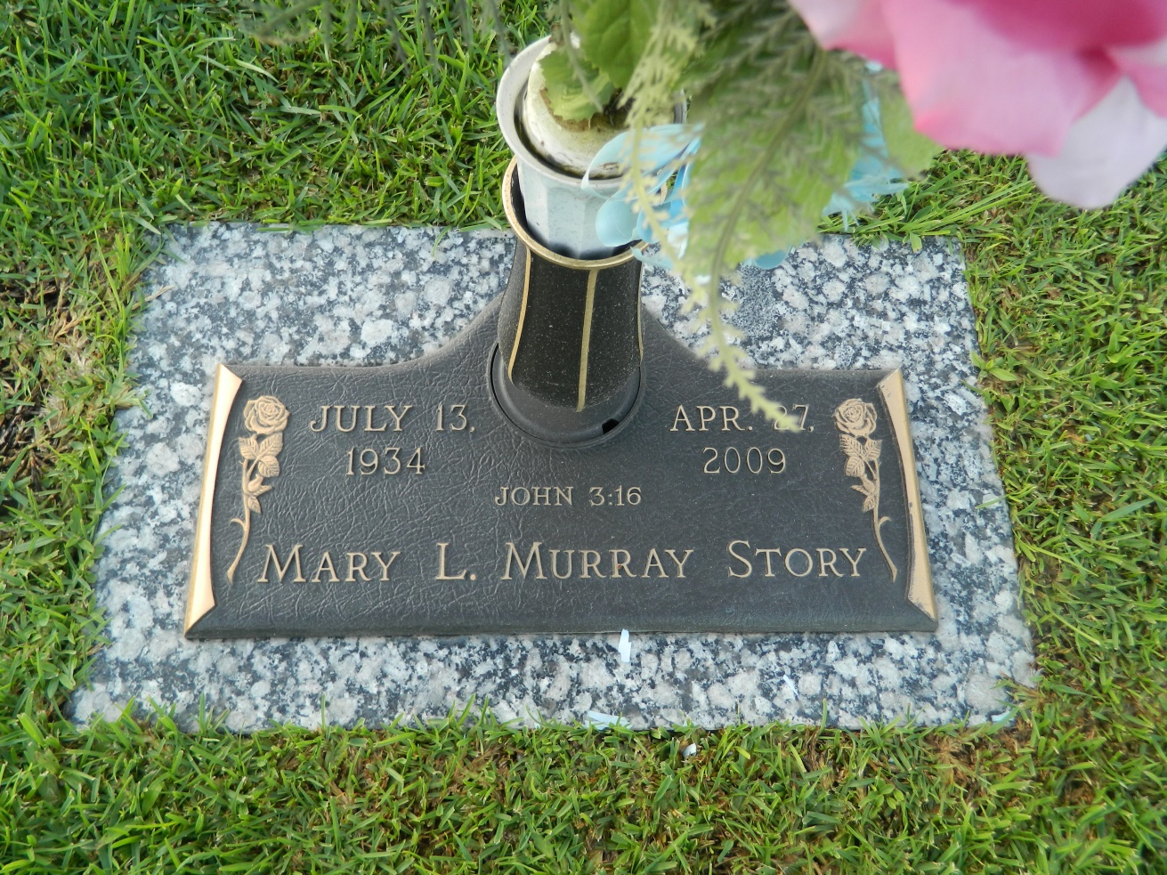

Mary Leah Murray Story on Monday, Apr. 27, 2009 at 12:53 pm. Beloved wife of the late Clarence Story. Mother of Doyle and wife Robin Story, Harold and wife Heidi Story, William Story, Kellie and husband Chris Tabb and Terri and husband Steve Mendoza. Daughter of the late Harold and Daisy Murray. Sister of James and Frank Murray. Also survived by 14 grandchildren and 10 great-grandchildren. Age 74. A native of McKinney, Texas and a resident of Reserve, La.  
  
Relatives and friends are invited to attend services. Visitation at Millet-Guidry Funeral Home, 2806 W. Airline, LaPlace, La., on Thursday, Apr. 30, 2009 from 12 noon to 2:00 pm. Followed by religious services in the Funeral Home Chapel at 2:00 pm. Burial in St. John Memorial Gardens Cemetery, LaPlace, La.

Times-Picayune, The (New Orleans, LA) - Wednesday, April 29, 2009

Contributed by Jane Edson