Bryant Strickland
August 9, 1922 – February 24, 2014

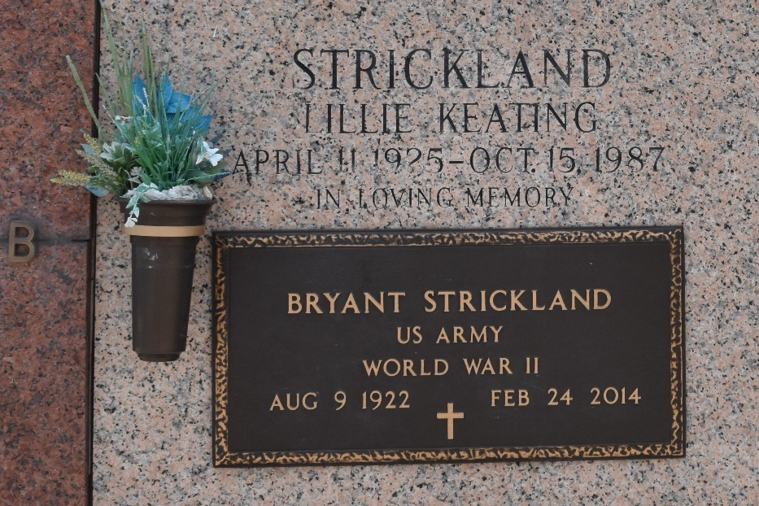

Bryant "Strick" Strickland died on Monday, February 24, 2014. Survived by family, friends and love ones. Age 91. A native of GA and a resident of LaPlace, LA.

Relatives and friends are invited to attend services. Visitation at The LaPlace Church of Christ, 115 Church St., LaPlace, LA on Thursday February 27, 2014 from 5:00pm to 9:00pm and on Friday from 8:00am to 10:00am, followed by Religious Services at 10:00am. Burial in St. John Memorial Gardens Cemetery, LaPlace, LA. Arrangements by Millet-Guidry Funeral Home, LaPlace, LA.

The New Orleans Advocate, Louisiana
Feb. 25 to Feb. 26, 2014

