Natalie (Craig) Sutton
March 27, 1961 – February 21, 2017

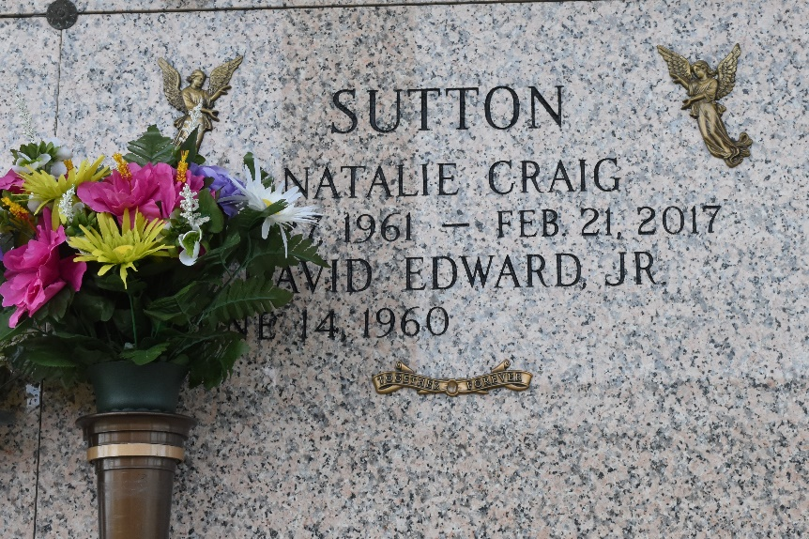

Natalie Craig Sutton passed away on Tuesday, February 21, 2017 at the age of 55. She was a native of Anaheim, CA and a resident of LaPlace, LA. Beloved wife of David E. Sutton, Jr. for 33 years. Mother of Jackie Sutton, Matthew Sutton (wife, Bridget) and Philip Sutton (fiancée, Hillary). Grandmother of Hallie Sutton, Trevor Sutton, and the late Jace Sutton. Daughter of Maj. Gen. Thomas L. Craig (Ret) and the late Alice Bailey Craig. Sister of Pamela Inge (husband, Bradley) and Laurie Sutton (husband, Mark). Also survived by many nieces and nephews.
Natalie was known by her grandchildren as "Pippa". She had the voice of an angel and is now singing in God's heavenly choir. The family would like to extend their heartfelt appreciation to the liver transplant team at the Mayo Clinic of Jacksonville, FL.
Relatives and friends are invited to attend the Funeral Mass at St. Joan of Arc Catholic Church, 529 W 5th Street, LaPlace, LA on Saturday, February 25, 2017 at 11:30 a.m. Visitation at the church from 9:30 a.m. until 11:30 a.m. Interment in St. John Memorial Gardens Cemetery. To view or sign the online guest book, please visit www.milletguidry.com.

The New Orleans Advocate, Louisiana
February 23-25, 2017

