Edward Henry Swible Jr.
September 21, 1955 – May 7, 2017

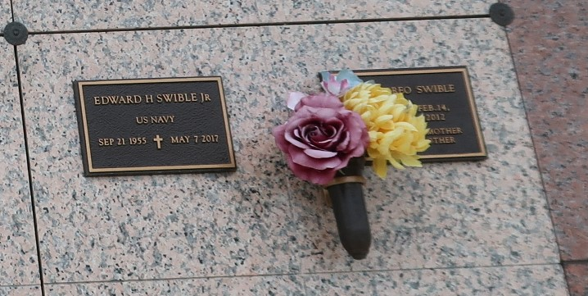

Edward "Butch" Henry Swible, Jr. passed away on Sunday, May 7, 2017 at the age of 61. He was a native of New Orleans and a resident of LaPlace. Butch graduated from Leon Godchaux High School and later joined the U.S. Navy. He was employed by LSU Health Science Center as an Information Technician and Supervisor. He was an avid LSU fan.
Preceded in death by his wife Ruth Abreo Swible and parents Edward H. "Boo Boo" Swible, Sr. and Miriam Oncale Swible. Butch is survived by his brother David A. Swible and stepchildren Michael J. Jaubert (Fran), Richard R. Jaubert (Susan), Marcel L. Jaubert (Shannon) and Janel J. Levet, step-grandchildren Emily Jaubert, Adrienne Jaubert, Erin Jaubert, Lauren Jaubert, Daniel Jaubert, René Jaubert, Louis Jaubert, Gabrielle Levet, Jeanne Levet and Madeleine Levet and two step-great-grandchildren.
Relatives and friends are invited to attend the Memorial Mass at St. Joan of Arc Catholic Church, 529 W. 5th Street, LaPlace, on Monday, May 15, 2017 at 11:00 a.m. Visitation will begin in church at 9:30 a.m. Interment in St. John Memorial Gardens Cemetery. Arrangements by Millet-Guidry Funeral Home. To view or sign the online guest book, please visit www.milletguidry.com.
The New Orleans Advocate, Louisiana
May 12-15, 2017

