Edward Henry Swible Sr.
July 8, 1931 – June 27, 2000

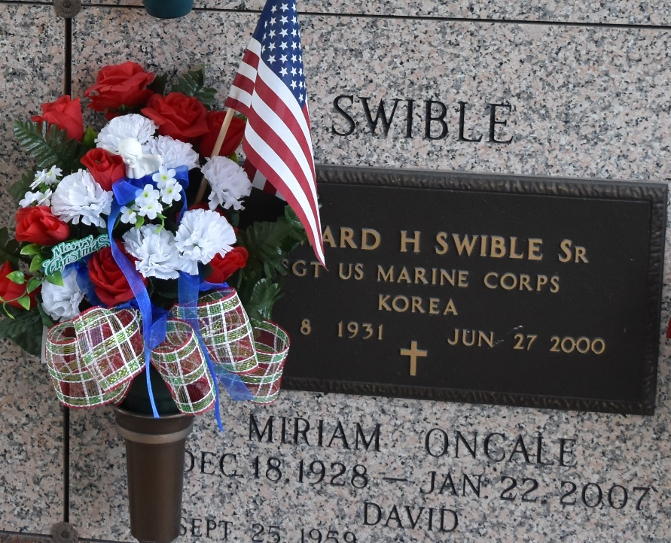

LAPLACE – Edward Henry Swible Sr., 68, a native of New Orleans and resident of LaPlace for 40 years, died June 27. He was the husband of Miriam Oncale Swible and father of Edward Jr. and David Swible. He was also the son of the late Edward J. and Juliana “Pepper” Gabler Swible and brother of Claire “Ronnie” Aldous, Juliana Cassard and the late John and Christopher Swible.
He was a past president and assistant chief of the LaPlace Volunteer Fire Department, past Grand Knight of the Knights of Columbus, past secretary of St. John Council on Aging, past secretary of A.A.R.P. and former sergeant of the United States Marine Corps Reserves. He was retired from Shell Chemical in Norco, where he worked for 32 years.
Services were June 30 at St. Joan of Arc Catholic Church, LaPlace, with interment at St. John Memorial Gardens, LaPlace.
L’Observateur, LaPlace, Louisiana
Saturday, July 1, 2000

