Miriam (Oncale) Swible
December 18, 1928 – January 22, 2007

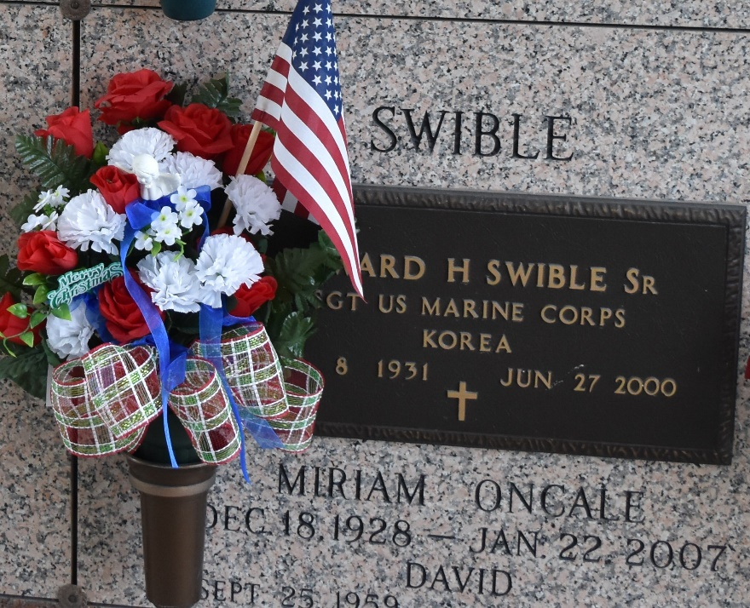

Miriam (Cat-T) Oncale Swible, on Monday, January 22, 2007 at 6:33 pm. Beloved wife of the late Edward Swible, Sr. Mother and mother-in-law of Edward, Jr. and Ruth Swible and David Swible. Daughter of the late Paul and Aline Oncale. Sister of Gene and Wilna Oncale, Carmel Laufer and the late Alex Rupert, Paul and Meredith Oncale and Marie Ory. Age 78. A native of Destrehan and a resident of Laplace.
Relatives and friends of the family, also Catholic Daughters are invited to attend services. Visitation at Millet-Guidry Funeral Home, 2806 W. Airline Hwy., Laplace, on Thursday, January 25, from 8 am to 9:45 am. Followed by religious services at St. Joan of Arc Catholic Church, Laplace at 10 am. Burial in St. John Memorial Gardens Cemetery, Laplace.
The Times-Picayune, New Orleans, Louisiana
Jan. 24, 2007

