Rudy ‘Jake’ Sylvain
May 3, 1944 – October 4, 2015

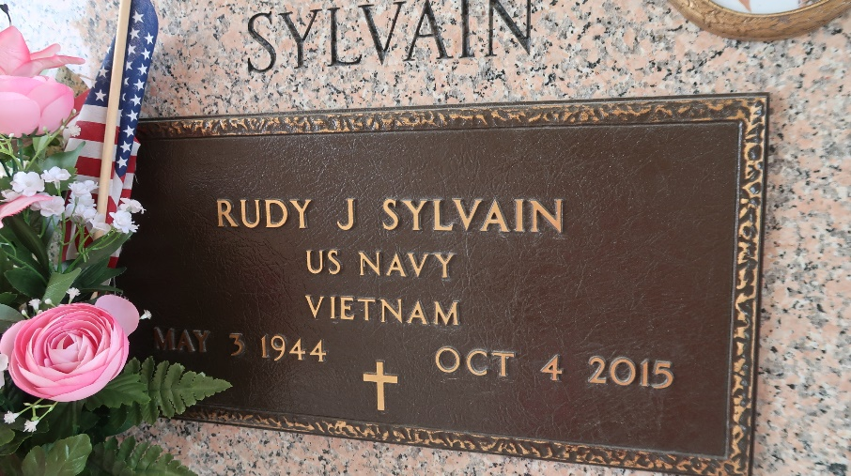

Rudy J. (Jake) Sylvain, was called to his heavenly home on Sunday October 4, 2015, when God dispatched his angels to his bedside. Age 71 yrs. Son of the late Joseph and Cleola Sylvain. Beloved husband of Audrey G. Sylvain. Father of Lisa (Kenneth) Cannon and Tanja (Dwayne) Dutton. Brother of Warner (Sandra), Donald, Joseph Michael Sr. (Edna Jean), Richard Ferdinand (Barbara), and Robert Carl (Dora) Sylvain. Nephew of Bertha Sylvain. Son-in-law of Mamie S. Gray. Survived by (6) grandchildren, a host of nieces, nephews, cousins, and friends.
Relatives and friends of the family , also priest and parishioners of Our Lady of Grace Catholic Church, St. John the Baptist Catholic Church, Providence B.C.#1 , Employees of Carbide/Dow Chemicals, Ray Brandt Toyota, Richardson ISD School System, members of VFW Post 3337 of LaPlace, La., Knights of Peter Claver, Council #73 , Second Ward High School Class of 1964 , are invited to attend a Mass of Christian Burial on Saturday October 10,2015 at 10:00am from the St. John the Baptist Catholic Church, 2349 LA. 18, Edgard, La. Father Christopher Amadi SSJ, celebrant. Visitation begins at 8;00am until Mass. Entombment St. John Memorial Garden Cemetery, LaPlace, La. A gathering of friends will be held on Friday October 9, 2015 from 4-6pm at Treasures of Life Center for Life Funeral Services, 315 E. Airline Hwy., Gramercy, La.

The Times-Picayune, New Orleans, Louisiana
October 8-9, 2015

