Lawrence Sylvan Sr.
September 21, 1923 – March 30, 2013

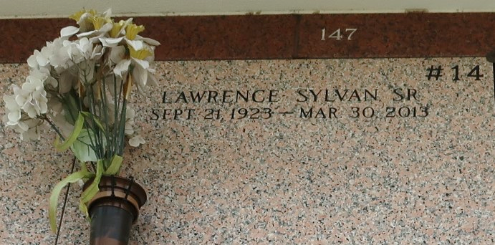

Lawrence Sylvan Sr. of LaPlace LA, departed this life on Saturday March 30, 2013 at the age of 89. He is preceded in death by his late wife Dora Sylvan, his parents Lillie Mitchell Sylvan and Jack Sylvan, brothers Charlie, Clarence, Joshua, and Melvin Sylvan.
He is survived by his children Lawrence Jr. (Tammy), Clarence (Shelby), Randell (Carolyn), and Randy Sylvan, Stepchildren: Robert Traywick (Charlotte), Frances Clark, Karen Turner, JoAnn Jones (Cedell), Cheryl Dorris (Romalis), Lori Marshall (Robert), Barbara Mitchell (Thaddeus), One sister Helen Morgan. Sister-in-laws Emma Sanders, Shirley Carter, Ethel Forest, Louise Brown (Chaffey), Gloria Lestrick , and Mary Lee Mitchell. A host of grandchildren, great grandchildren, nieces, nephews, other relatives and friends.
Relatives and friends of the family are invited to attend the funeral service on Friday April 5, 2013 at 11:00 AM at the Rising Star Baptist Church 620 Cardinal Street, LaPlace LA. Pastor Donald August of the Rising Star Baptist Church will be officiating. Visitation will be from 9:00 AM - 11:00 AM. Interment: Saint John Memorial Gardens of LaPlace. Arrangements by D.W. Rhodes Funeral Home of New Orleans, LA.

The Times-Picayune, New Orleans, Louisiana
April 4-5, 2013

