Shelby Marie (Grimsley) Sylvan
Unknown - April 13, 2018

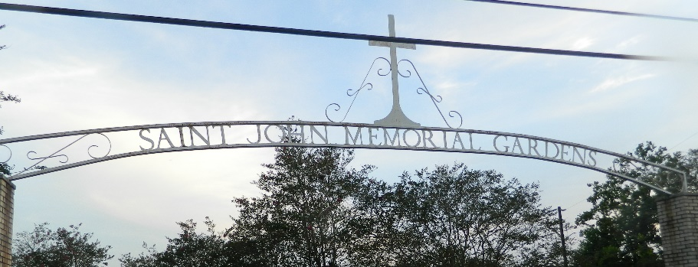

Shelby Marie Grimsley Sylvan pass away on Friday April 13, 2018, Wife of Clarence Sylvan, Mother of Clarence Jr and Jordan Sylvan, Daughter of George and Leona Grimsey. Sister of Marcelous, Michael, Melissa, George, III, Simeon and Justine Grimsley. Shelby is survived by nieces, nephews, great nieces, great-nephews, brothers and sisters in laws and a host of other relatives and friends. Service will be on Saturday April 21, 2018 at Kingdom Hall of Jehovah witnesses reserve Congregation 500 colony park Dr. Laplace, La 70068 at 2:00pm. Brother Michael Dunn officiating. Interment in St. John Memorial Gardens Laplace La. Professional Services entrusted to the caring staff Hobson Brown Funeral Home, 134 Daisy St., Garyville, La 70051, 985-535-2516.
The New Orleans Advocate, Louisiana
April 19-21, 2018

