Vondel Anise Sylvan
December 28, 1966 – June 23, 2018

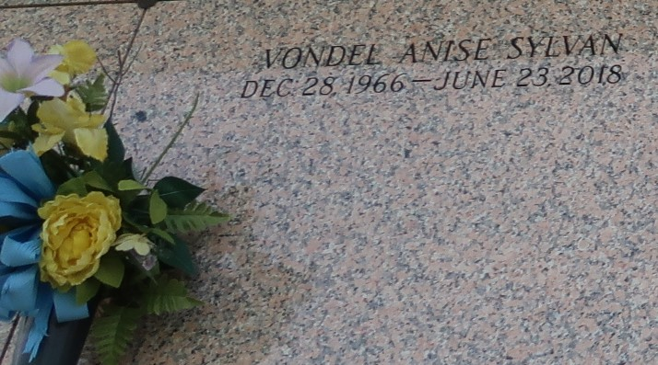

Vondel Anise Sylvan departed this life on Saturday, June 23, 2018 at the age 51. Daughter of the late Lonnie and Carmella August Sylvan. Mother of Vallen Carmella Louise Snyder. Sister of Millicent Van Norden, Lonnie Lamont and Rhemy Sylvan. Aunt of Kiki Thompson, Mya Jones, Josiah, and Lonnie Lamar Thompson Sylvan, Laten, Atyra and Satyra Vinnetta, Cain, Loki Van, and Christian Van Norden. Great aunt to Lani Thompson and Landon Thompson Sylvan. Vondel is survived by a host of other relatives and friends.
Funeral Service will be on Friday, June 29, 2018 at Rising Star B.C., 620 Cardinal St., Laplace, La, at 11:00 am. Pastor Donald August, officiating. Visitation on Friday at 9 am until Service time. (ONLY) Interment in St. John Memorial Gardens Laplace, La. Professional Services entrusted to the caring staff of Hobson Brown Funeral Home, 134 Daisy St. Garyville, La 70051. 985-535-2516.
TheNewOrleansAdvocate.com
June 27-29, 2018

