Joshua Joseph Tabb

November 15, 1980 – May 18, 2003

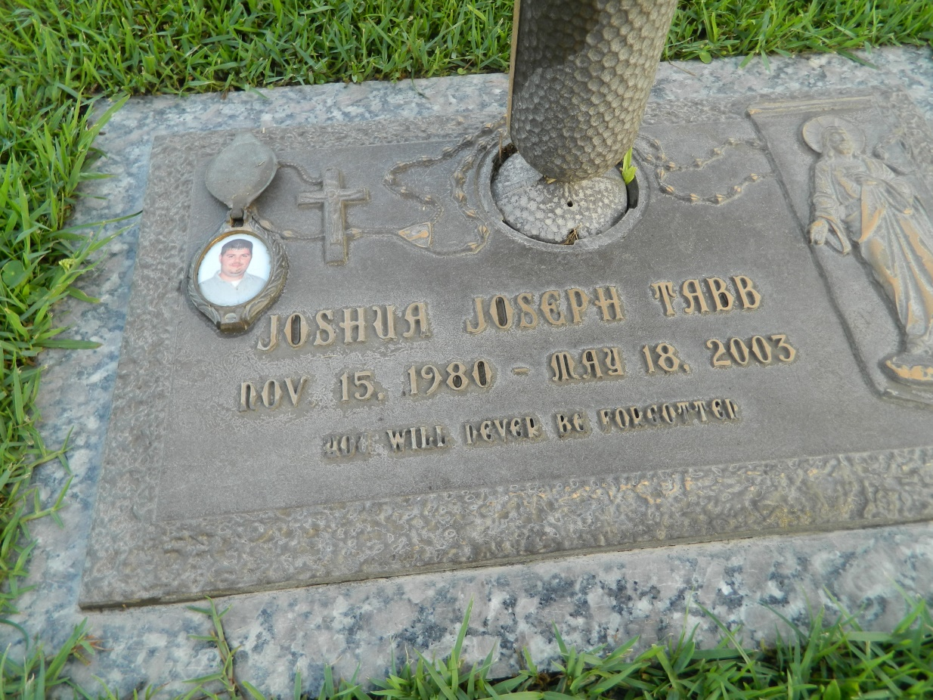

Joshua Joseph Tabb on Sunday, May 18, 2003 at 3:00am. Beloved son of Wilfred Tabb and Pamela Mayeux. Brother of Shantel and Anthony Tabb. Grandson of Lunis Trahan and the late Joseph Trahan and the late Allen and Nora Duhe Tabb. Also survived by a host of other relatives and friends. Age 22 years. A native and lifelong resident of Montz, LA.  
  
Relatives and friends of the family are invited to attend the services. Visitation at Millet Guidry Funeral Home, 2806 W Airline Hwy, Laplace, LA, on Tuesday, May 20, 2003 from 5:00 PM to 10:00 PM and on Wednesday morning from 8:00 AM - 9:45 AM. Followed by religious services at St. Joan of Arc Catholic Church, Laplace at 10:00 AM. Burial in St. John Memorial Gardens, Laplace, LA.

Times-Picayune, The (New Orleans, LA) - Tuesday, May 20, 2003

Contributed by Jane Edson