Hazel O. (Landry) Tamplain
March 3, 1930 – November 19, 2013
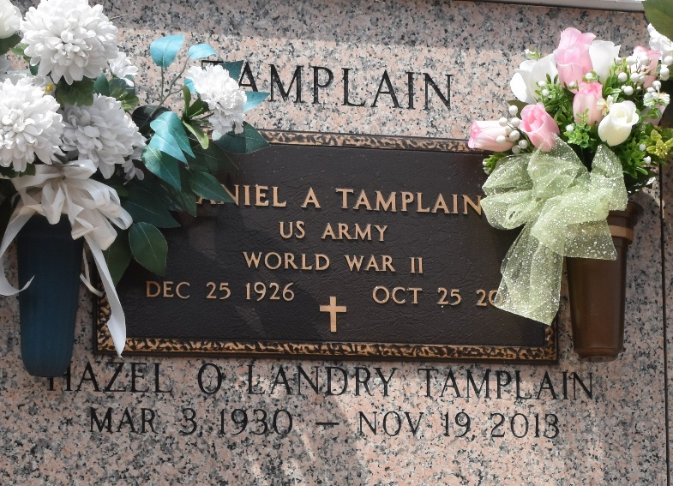

Hazel Ockman Landry Tamplain died on Tuesday, November 19, 2013 at 11:50 am. She was the Beloved wife of Daniel A. Tamplain and by 1st marriage of the late Jessie J. Landry. She was born at home in Vacherie, LA on March 3, 1930 to her parents Amy Rome Ockman and Charles Ockman. She was raised with her beloved sisters Frances Ockman St. Martin, Ruby Ockman Brignac, Anna Lee Ockman Calcagno, Marion Ockman Keating and Janice Ockman Oncale, all preceeding her in death. Hazel was the mother of Charles "Chuck" Landry (Margaret), Patsy Landry Thom (Larry), Sandy Landry (Heidi) all of LaPlace and Brian Landry (Sabina) of Paulina. Step-mother of Danielle Vicknair (Steve) of Montz and the late Terry and Chris Tamplain of Garyville. Grandmother of Stacy Remondet (Matt), Clint Landry (Jessica), Scott (Cynthia), Brandon (Kristin) and Rhett (Jennifer) Brunet, Preston and Dalton Landry, Brittni Addison (Shane), Kaley Frederick (Josh) and Jessie Loescher (Henry). Step-grandmother of Stevie Vicknair and Scott Terrio. Also survived by 14 great-grandchildren.
Hazel was 83 and a resident of LaPlace, LA for 76 yrs. She was a parishioner of St. Joan of Arc Catholic Church. She was an active member of the St. Joan of Arc Ladies Altar Society, Msgr. Bergeron KC Auxillary and St. Joan of Arc Thrift Shop.
Relatives and friends are invited to attend services. Visitation at St. Joan of Arc Catholic Church, 529 W. 5th St., LaPlace, LA, on Friday, November 22, 2013 from 9:30 am to 1:00 pm, followed by Mass at 1:00 pm. Burial in St. John Memorial Gardens, LaPlace, LA. Arrangements By Millet-Guidry Funeral Home, LaPlace, LA.

The Times-Picayune, New Orleans, Louisiana
Nov. 20 to Nov. 22, 2013

