Kathleen (Harrison) Tassara
June 25, 1926 – October 22, 2021
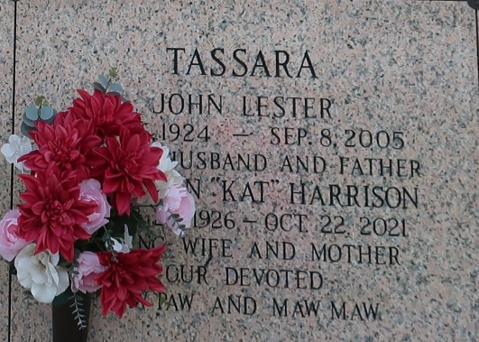

Kathleen "Kat" Harrison Tassara passed away peacefully at her home, surrounded by family and friends on Friday, October 22, 2021. She was 95, a native of Killen, AL and a resident of Reserve, LA. Kat was happily married to John Tassara, for 63 years until his death in 2005.
She was a great cook, who passed down many family recipes to her children. Kat touched the lives of everyone who knew her and was a very caring and generous person, who was always willing to help others. She was loved by everyone who she came in contact with. Jesus held a special place in her heart.
Loving mother of Daniel Tassara (Robbie), Peggy Watson (the late James), Debbie Berget, Kathy Sellars (Glenn), John Tassara, Jr., and Mike Tassara (Elaine). Also survived by twenty-two grandchildren, forty-seven great grandchildren, twenty-two great great grandchildren and numerous nieces and nephews.
Preceded in death by her husband of 63 years, John Tassara; parents, James and Myrtle Harrison; sisters, Betty Elliot and Ruth Jennings; and two grandchildren, Michelle Tassara and Glenn Sellars, Jr.
Relatives and friends are invited to attend the Funeral. Visitation at LifeHouse Church, 3556 W. Airline Highway, Reserve, LA on Friday, October 29, 2021 from 9:00 a.m. until Funeral Service at 11:00 a.m. Interment in St. John Memorial Gardens Cemetery, LaPlace, LA.
Millet-Guidry Funeral Home, LaPlace, Louisiana
October 27, 2021

