Irving C. Tassin Jr.

December 16, 1938 – April 16, 2003

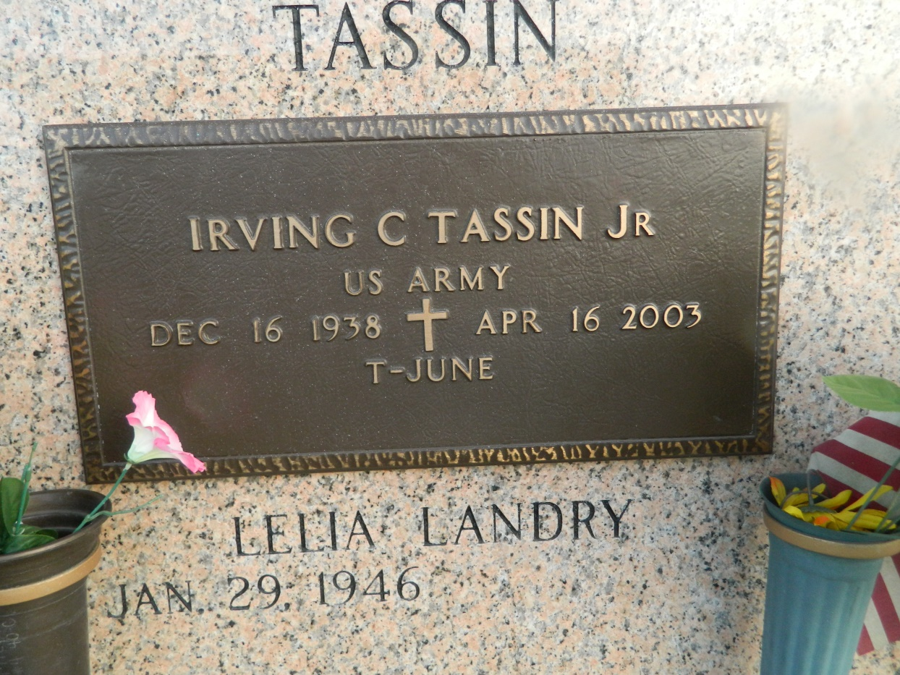

Irving C. Tassin, Jr. on Wednesday, April 16, 2003 at 11:45 PM. Beloved husband of Lelia Landry Tassin. Father of Lonnie and Todd Tassin, Kathy Corbin and Debbie Tassin. Son of the late Irving, Sr. and Lelia Tassin. Brother of Donald Tassin. Also survived by 5 grandchildren. Age 64. A native and resident of LaPlace.  
  
Relatives and friends of the family are invited to attend services. Visitation at Millet-Guidry Funeral Home, 2806 West Airline Hwy, LaPlace on Monday, April 21, 2003 from 5PM-10PM and on Tuesday from 8AM-10AM followed by religious services in the funeral home chapel at 10AM. Burial in St. John Memorial Gardens, LaPlace.

Times-Picayune, The (New Orleans, LA) - Friday, April 18, 2003

Contributed by Jane Edson