Jayla Nicole Tassin
April 27, 2000 – July 21, 2019
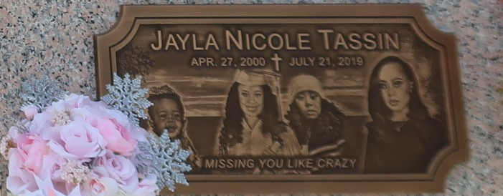

Jayla entered this world on April 27, 2000. She departed this life on July 21, 2019 at Halifax Medical Hospital in Daytona Beach, Florida. Jayla is survived by her mother Evan Nelson, her father Bernard Tassin, III and stepmom Delisa Tassin. She is the sister of Javon Houston, Javor Stemley, Jazlyn Frith, Jaden Tassin, Amari Tassin, and Armad Tassin. She is also survived by her maternal grandmother Alma Lee Bailey, her paternal grandparents, Peggy and Aaron Joseph, also a great grandmother, Geraldine Millet. She was the niece of Tanya Bailey, Shanda Bailey, Niya Bernard, Angela Joseph, Teel Fleming, Brent Tassin, Staffon McKinley, and Aaron, Anthony, and Ashton Joseph. She also leaves her Godparents, Pamela Perrilloux and Pastor Joseph D. Johnson, along with her only Godchild, Jarie'ion Knighton.
Jayla was preceded in death by grandparents Lawrence Bailey, Jr. and Bernard Tassin, Jr. Jayla was a 2019 graduate of East St. John High School, and was planning to attend University of Louisiana at Lafayette on August 18, 2019. She was employed by St. John the Baptist Parish Summer Camp and was a member of Destiny Christian Center in LaPlace, Pastor Steve O. Allen, Sr.
Everyone is invited to attend "Jayla's Celebration of Life" beginning with a public viewing on Friday, August 2, 2019 from 6:00 pm-7:30 pm at Destiny Christian Center, 612 Main Street in LaPlace, LA. Celebration service will be on Saturday, Aug. 3, 2019 10:00 am at New Wine Christian Fellowship, Viewing begins at 8:00 am- 1929 West Airline Hwy in LaPlace, LA. Pastor Neil Bernard; Pastor Steve O. Allen, Sr., officiating. Entombment to follow at St. John Memorial Gardens, Airline Hwy, LaPlace, LA. Her final care has been entrusted to Treasures of Life Funeral Services, 315 E. Airline Hwy., Gramercy, LA 70052.

The Times-Picayune, New Orleans, Louisiana
Aug. 1 to Aug. 2, 2019

