Mildred (Cambre) Tassin
July 3, 1927 – April 10, 2003
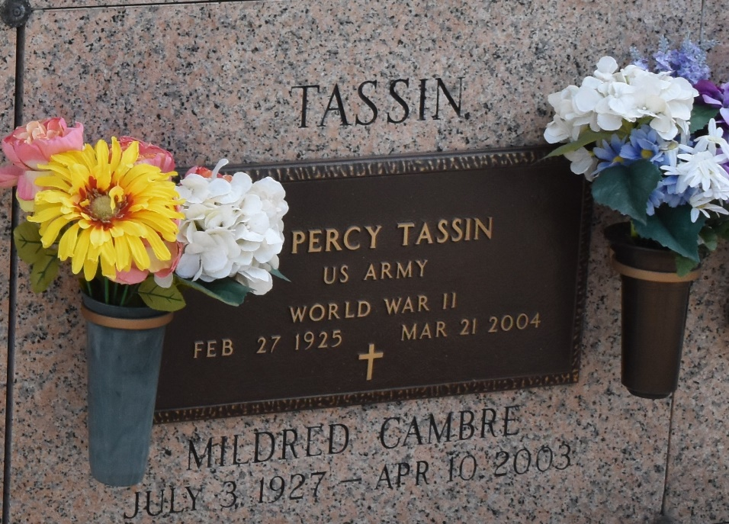

Mildred Cambre Tassin on Thursday, April 10, 2003 at 3:20 p.m. Beloved wife of Albert Percy Tassin. Mother of Shirleen T. Biscoe, Deana T. Holmes, Janet T. Frederick, Marsha T. LaBranche and Darlene T. Dean. Mother-in-law of Robert K. Biscoe, Charles Lee Holmes, Joey LaBranche and Thomas Dean. Grandmother of Nicole and April LaBranche, Rebecca Day, Jeffrey and Brittany Holmes and B.J. Frederick. Age 75. A native and resident of Laplace.

Relatives and friends of the family also members of the Catholic Daughters of America, AARP, VFW Auxilliary and German-Acadian Coast Historical and Genealogical Society are invited to attend services. Visitation at Millet-Guidry Funeral Home, 2806 W. Airline Hwy. Laplace on Sunday, April 13, 2003 from 5 to 10pm and on Monday from 8am to 10am, followed by religious services in the funeral home chapel at 10am. Burial in St. John Memorial Cemetery, Laplace.

The Times-Picayune, New Orleans, Louisiana
April 12-13, 2003

