Ceola (Cambre) Taylor
October 6, 1926 – May 5, 2021

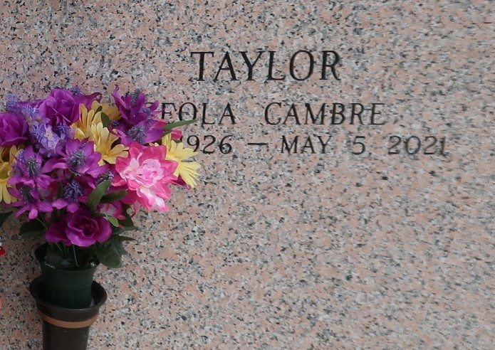
Ceola C. Taylor peacefully gained her crown and heavenly wings on Wednesday, May 5, 2021, at the grand age of 94 years young, surrounded by family. She was born on October 6, 1926, to the late Christopher and Fedora Wiltz-Cambre. She was the youngest of five children.
Ceola was married to Alex Taylor until his passing in 1966. She later found companionship with the late Walter (Ning) Stewart. She had five children - Ernestine Taylor Taplin (Fred), Dora Nevers (Gary), Dianne Jackson, Michael Taylor (Melanie), and Patricia Armour (Duranne). She is survived by her children, 10 grandchildren, 12 great-grandchildren and a host of nieces and nephews.
Ceola worked as a food service technician at Louis Armstrong International airport but if you asked her, her true job was caring for her family. Ceola accepted Christ at a young age and was a faithful member of True Light Baptist Church in Garyville, LA. where she attended on a regular basis until her health prevented her to do so. Her favorite songs were "One Day at a Time" and "Let Jesus Fix it" her favorite scriptures were the 23rd Psalms and Matthew 18:21-35.
Ceola was preceded in death and welcomed to heaven by her parents, Christopher and Fedora Cambre, her grandparents Mary and Lawrence Wiltz, her husband, Alex Taylor, companion Walter Stewart, her siblings, Mable, Edgar Sr, Iola, and Edith, and a host of nieces and nephews.
A Home going Celebration will be held on Wednesday May 12, 2021, at Bethlehem Baptist Church 146 East 20th St Reserve, LA at 11am, Pastor Forell Bering officiating. Visitation will be Tuesday May 11, 2021, at Hobson-Brown Funeral home 134 Daisy St Garyville, La from 4pm-6pm and Wednesday May 12th, 2021, at Bethlehem Baptist Church from 9am-11am ONLY. Burial will follow at St. John Memorial Gardens. There will be no repast. Due to CDC (Covid19) restrictions seating is limited, mask and social distancing are required. Professional Services entrusted to the Caring Staff of Hobson Brown Funeral Home, 134 Daisy St., Garyville, LA 70051. 985-535-2516.
The Times-Picayune (New Orleans, Louisiana)
May 9 to May 12, 2021

