Michael A. Taylor Jr.
April 11, 1980 – June 26, 2008

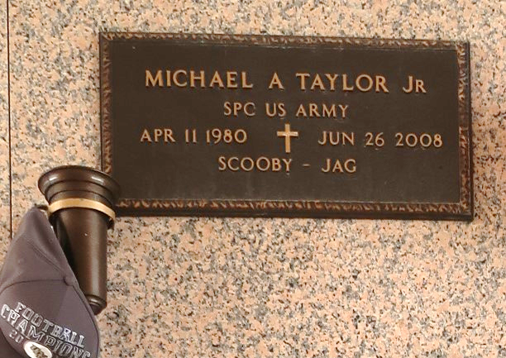

Michael A. (Scooby, Jag) Taylor, Jr., age 28, a United States Army Veteran, departed this life on Thursday, June 26, 2008 in Garyville, La. Son of Priscilla James and the late Michael Taylor, Sr. and stepson of Charles James. Father of Jordan Hayes. Brother of Whitney and Shontell James, Marcus Kliebery and Kendell Morris. Grandchild of Dora Mae and Charles Lee Belvin, Sr., and the late Shirley Mae and Lawrence Taylor, Sr. A devoted friend of Brandy Hayes. Also survived by a host of aunts, uncles, nieces, nephew, godchildren, other relatives and friends. A native and resident of Garyville, La.

Pastors, officers and members of True Light B.C. and all neighboring churches are invited to attend the Funeral Service on Saturday, July 5, 2008 at 10:00 a.m. from the above named church, 258 Little Hope St., Garyville, La. Rev. Wesley Anderson, Sr., Pastor - officiating. Viewing on Saturday at the church from 9:00 a.m until service time. Interment in St. John Memorial Gardens, Laplace, La. Service entrusted to Hobson Brown Funeral Home Garyville, La.
The Times-Picayune (New Orleans, Louisiana)
July 4, 2008
Contributed by Jane Edson

