Carris J. Tezeno Sr.
February 15, 1943 – July 10, 2015

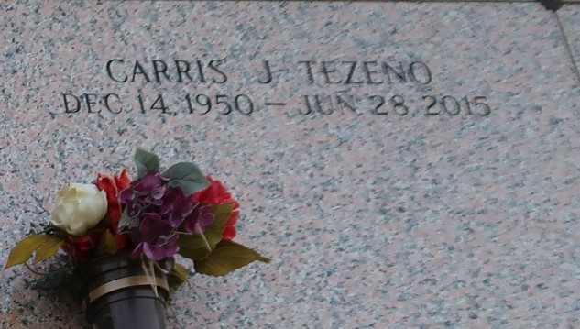

Carris Tezeno Sr., age 64 passed on June 28, 2015.
Son of Jaushia Tezeno and the late Viola Leday, Husband of Addie J. Tezeno. Survived by (7) children, (2) step-children, (2) Brothers, and a host other relatives and friends.
Funeral service on Saturday, July 11, 2015 at Mt. Calvary B.C. 127 W. 3rd St. Laplace, La, at 11:00am. Visitation at 9:00am until service time. Dr. Freddie Howard Pastor officiating. Internment St. John Memorial Gardens Laplace, LA. Service Entrusted to Hobson Brown Funeral Home Garyville, La 70051 985-535-2516

The Times-Picayune, New Orleans, Louisiana
Jul. 10 to Jul. 12, 2015

